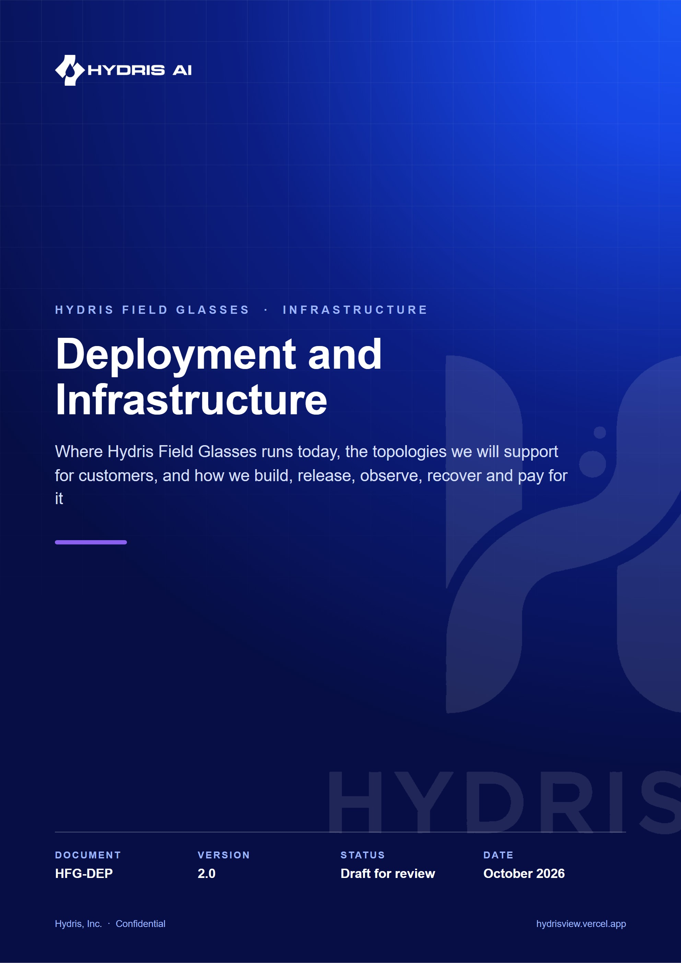
Document control
Document | Deployment and Infrastructure (HFG-DEP)
Version | 2.0
Status | Draft for review
Owner | Platform engineering, Hydris
Audience | Platform and backend engineers, DevOps, security reviewers, customer IT and OT teams, pilot programme leads
Product | Hydris Field Glasses: website, operator console, glasses app, Android app, API
Source of truth | docs/product/DEPLOYMENT.md in tarun-km/hydrisview (this Word file is generated from it)
Classification | Confidential: Hydris, Inc. and named partners
Revision history
Version | Date | Author | Changes
2.0 | October 2026 | Platform engineering, Hydris | Rewritten as a full infrastructure reference. Adds target topologies (India region, plant edge, hybrid), environment matrix, full configuration reference, proposed CI/CD, migrations and rollback, Android distribution, observability with SLOs, backup and DR, capacity and cost models, India residency and a go-live checklist

Contents
1 Deployment at a glance 5
2 Where Hydris runs today 7
2.1 The current production topology 7
2.2 Demo mode and how it is selected 8
2.3 Cross-instance demo state 9
2.4 What exists and what does not 10
3 Target topologies 11
3.1 Topology A: managed SaaS on Vercel and Neon 11
3.2 Topology A-IN: India region 12
3.3 Topology B: Vercel web with a container API 12
3.4 Topology C: on-premises or plant-edge install 13
3.5 Topology D: hybrid with an edge gateway 15
3.6 Choosing a topology 17
4 Environment matrix 19
5 Configuration reference 20
5.1 Variables validated by config.ts 20
5.2 Variables read directly from the environment 21
5.3 Android build properties 21
5.4 Secrets handling rules 21
6 Build and release pipeline 23
6.1 How a release happens today 23
6.2 Release versioning 23
6.3 Release train 23
7 Proposed CI/CD with GitHub Actions 24
7.1 Pipeline design 24
7.2 Example workflow 25
7.3 Gates and policies 26
8 Database migrations and rollback 27
8.1 How migrations run 27
8.2 Managed Postgres prerequisites 27
8.3 Expand and contract 27
8.4 Rollback 29
9 Background jobs and scheduling 30
9.1 Jobs that exist 30
9.2 The daily cron problem 30
9.3 Job design rules for new jobs 31
10 Android app distribution 32
10.1 Distribution channels 32
10.2 Signing keys 33
10.3 Enterprise MDM configuration 34
11 Observability 35
11.1 Current state 35
11.2 Target architecture 35
11.3 Key metrics 36
11.4 Service level objectives 36
12 Backup and disaster recovery 38
12.1 Objectives 38
12.2 Backup schedule 38
12.3 Disaster scenarios 39
12.4 Restore runbook 39
13 Scaling and capacity 41
13.1 What limits scale today 41
13.2 Capacity model 41
14 Cost model 43
15 India data residency and regulatory hosting 45
15.1 Residency design 46
16 Customer onboarding and provisioning 47
16.1 Provisioning flow 47
16.2 Onboarding steps and owners 47
17 Go-live checklist 48
17.1 Platform 48
17.2 Pipeline 48
17.3 Operations 48
17.4 Customer 48
18 Known gaps and decisions 49

This document describes how Hydris Field Glasses is deployed today and how it will be deployed for paying customers. It covers the hosted platform on Vercel, the managed Postgres database, the two Android apps, the release pipeline that ships them, and the operational practices (observability, backup, disaster recovery, capacity, cost and data residency) that turn a working demo into a dependable service for wastewater and effluent treatment plants.
Every statement about the current system is grounded in the repository and names the file it comes from. Status labels follow the house rule: Built means it is in the code and exercised, Partial means it exists but has a known gap, and Planned means it is a design that is not yet implemented. Targets are labelled as targets. Costs and capacity numbers are indicative estimates, not measurements or quotes.
1  Vercel project  website, console, glasses app and API in one deployment |  | 9  SQL migrations  `apps/api/drizzle/0000` to `0008`, applied under an advisory lock |  | 0  CI workflows  no `.github/` directory yet; the pipeline in this document is proposed |  | 1  daily cron  `/api/cron` at `0 3 * * *` (root `vercel.json`)

IMPORTANT
The live deployment at https://hydrisview.vercel.app is a demonstration environment. It runs in demo mode with synthetic data and public demo secrets. It must never receive real plant data. The production topologies in this document are what a customer pilot runs on.

1 Deployment at a glance
Hydris is a TypeScript monorepo (package.json workspaces packages/* and apps/*, Node 22.x in engines). Three deployable units come out of it:
Unit | Source | Runtime | Status
Web and API | apps/web (Next.js 16) with apps/api (Fastify) compiled in | Vercel serverless functions, Node.js runtime | Built
Hydris Field (native Android) | apps/android (Kotlin, Jetpack Compose) | Android 12+ phones, package ai.hydris.field | Partial (release signing not configured)
Hydris Glasses bridge (Android) | apps/glasses-bridge-android (WebView plus Meta Wearables DAT 1.0.1) | Android 12+ phones paired to Ray-Ban Meta glasses, package ai.hydris.glassesbridge | Partial (not yet run on physical glasses, per its README)

Two further artefacts exist for non-Vercel hosting and are used by the target topologies:
Artefact | File | Purpose | Status
API container image | apps/api/Dockerfile | Long-running Fastify server (src/server.ts) with timers, SSE and local disk storage | Built, not used in production
Web container image | apps/web/Dockerfile | Next.js server that proxies /api to API_URL | Built, not used in production
Compose stack | docker-compose.yml | Postgres 17, API and web on one host | Built, used for local production-like tests
Render blueprint | render.yaml | API as a Render web service with a 5 GB disk | Built, not deployed

NOTE
Both Dockerfiles use node:24-slim, while the root package.json pins engines.node to 22.x and docs/operations/vercel.md asks for Node 24 in the Vercel project settings. Pick one major version for all runtimes before the pilot. This document assumes Node 22 because that is what engines enforces.

2 Where Hydris runs today

2.1 The current production topology
The whole product is one Vercel project connected to the GitHub repository tarun-km/hydrisview. Every push to main triggers a production build and deployment to https://hydrisview.vercel.app. The root vercel.json sets the framework (nextjs), the install command (npm ci --include=dev), the build command (npm run build, which builds only @hydris/web), the output directory (apps/web/.next) and a single cron job.
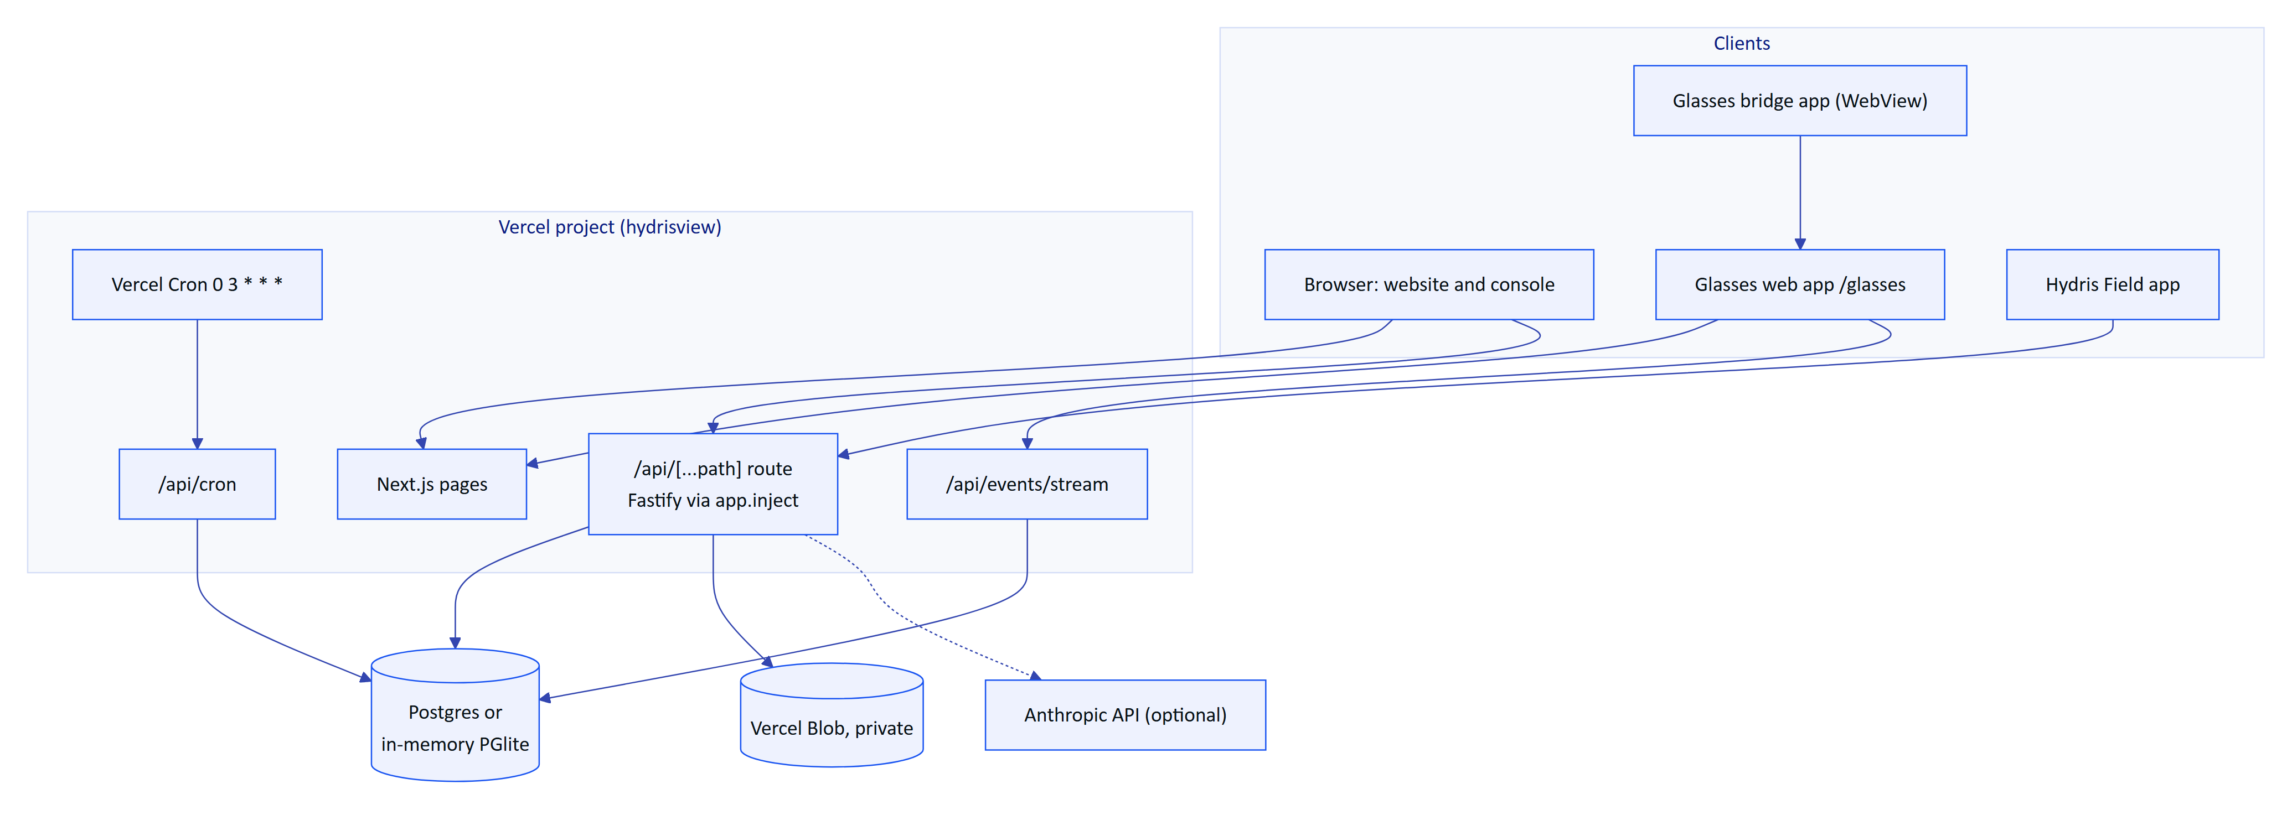
Figure 1. Current deployment: one Vercel project serves the website, console, glasses app and the API in-process
The API is not a separate service. apps/web/src/app/api/[...path]/route.ts lazily imports @hydris/api/serverless, builds the Fastify application once per function instance and forwards each request with app.inject (no network hop). Next.js treats it as an ordinary route handler with runtime = 'nodejs', dynamic = 'force-dynamic' and maxDuration = 60. The next.config.ts file keeps native and runtime-plugin packages (@node-rs/argon2, pg, @electric-sql/pglite, fastify and its plugins, @vercel/blob) out of the bundle via serverExternalPackages, and ships the SQL migrations with the functions via outputFileTracingIncludes.
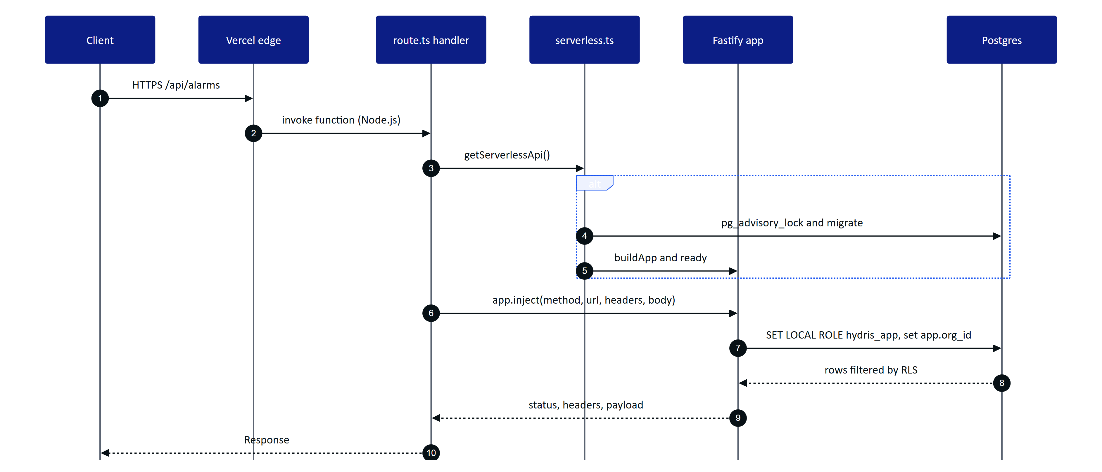
Figure 2. Request path for an API call in the built-in API mode
Two route handlers bypass app.inject because they need host-level behaviour:
- apps/web/src/app/api/events/stream/route.ts streams Server-Sent Events from the realtime_events table for up to 50 seconds, then ends with a retry: hint so the client reconnects with Last-Event-ID. It refuses to run unless REALTIME_MODE=db, because an in-memory event bus cannot span serverless instances. Built.
- apps/web/src/app/api/cron/route.ts runs one pass of the background jobs when called with Authorization: Bearer $CRON_SECRET, compared in constant time. Built.
When API_URL is set (or in next dev), next.config.ts adds a beforeFiles rewrite that proxies /api/* to that URL instead, so the same web build can front an external API container. This switch is the hinge between the serverless topology and the container topologies below.

2.2 Demo mode and how it is selected
apps/api/src/config.ts decides at start-up whether the instance is a demo. isDemoEnv returns true when DEMO_MODE=true, false when DEMO_MODE=false, and otherwise true when running on Vercel (VERCEL set) without a DATABASE_URL. In demo mode demoDefaults forces DATABASE_URL=memory:// (an in-memory PGlite database per instance) unless DEMO_PERSIST=true and a Postgres URL are both present, fills in the public DEMO_SECRETS for any missing or invalid JWT_SECRET and DATA_KEY (and logs a warning), derives PUBLIC_APP_URL from VERCEL_PROJECT_PRODUCTION_URL or VERCEL_URL, and forces SIMULATOR_ENABLED=true and REALTIME_MODE=db.
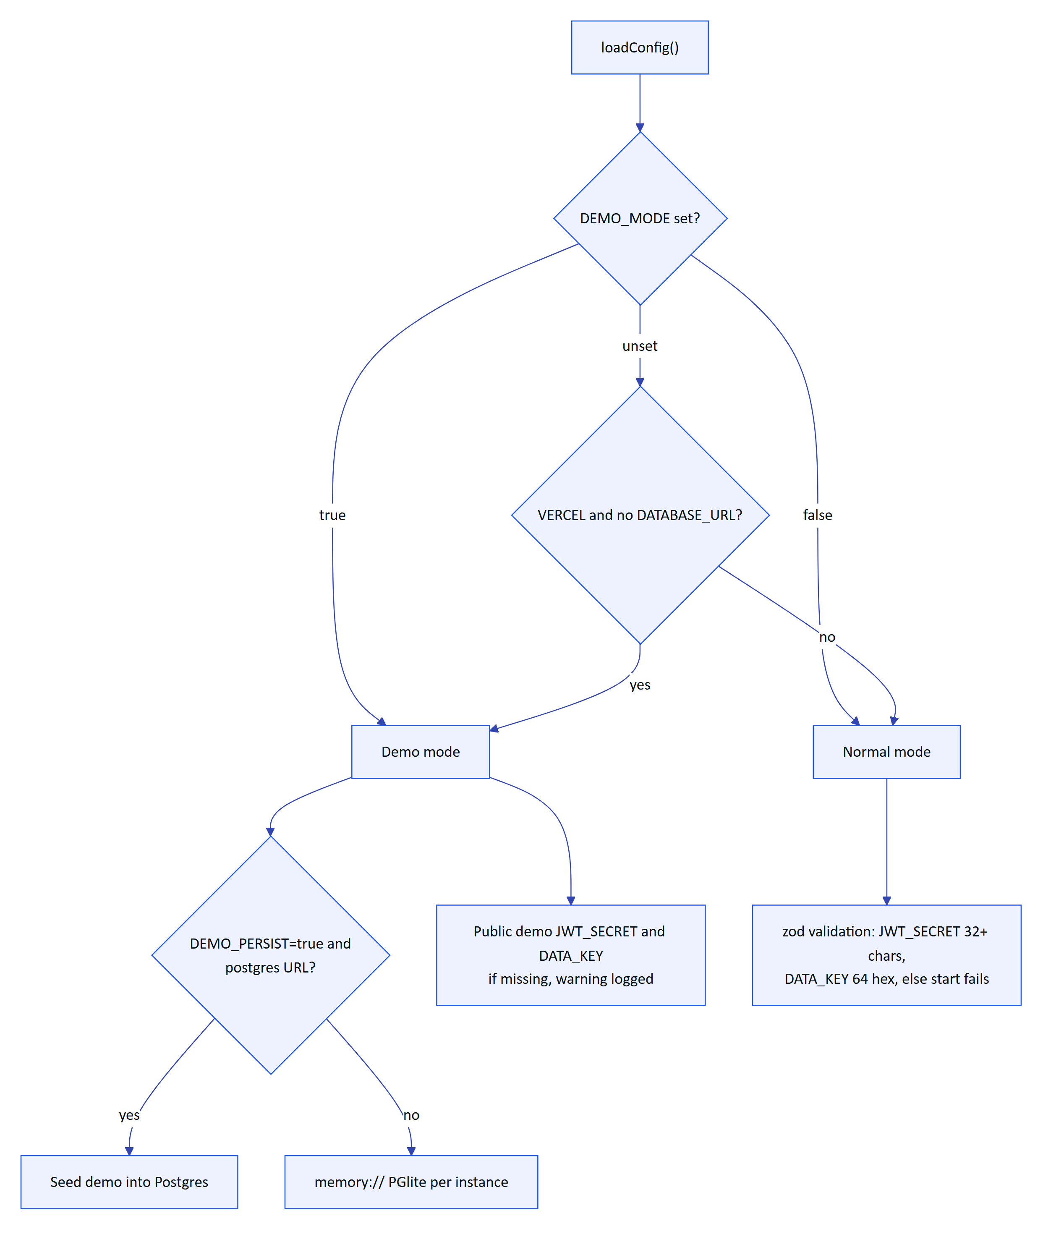
Figure 3. How config.ts chooses between demo mode and a real deployment
Demo mode always behaves as serverless (no interval timers). Its access tokens live 12 hours instead of 15 minutes (accessTokenTtl) because sessions live per instance. Each instance seeds the same deterministic synthetic tenant on cold start (bootDemo in apps/api/src/demo.ts).

2.3 Cross-instance demo state
Because every demo instance has its own database, short-lived state that must be seen by more than one instance (a pairing challenge and its approval, a named guest account) goes through a tiny key/value store, apps/api/src/core/demo-shared.ts. It selects a backend in order of preference and wraps it so that a failure never breaks the demo.
Backend | When | Scope | Persistence | Status
Postgres hydris_demo_kv | A Postgres DATABASE_URL is present | All instances using that database | Until expires_at | Built
Vercel Runtime Cache | On Vercel without Postgres | All instances in one region | Best effort, TTL based | Built
Process memory | Local development and tests | One process | Until restart | Built

WARNING
Demo mode relaxes several security properties on purpose (public signing secrets, 12-hour access tokens, self-contained device refresh tokens, self-approval in demo tenants). That is acceptable only because demo data is synthetic and flagged is_demo. The Security and Privacy document (HFG-SEC) lists these relaxations.

2.4 What exists and what does not
Table 1. Demo shared-state backends in apps/api/src/core/demo-shared.ts
Capability | Status | Evidence
Git-driven deploys to Vercel (preview per branch, production on main) | Built | Vercel Git integration, root vercel.json
In-process API on serverless functions | Built | apps/web/src/app/api/[...path]/route.ts, apps/api/src/serverless.ts
Migrations on cold start under an advisory lock | Built | createDatabase().migrate in apps/api/src/db/client.ts
Migrations in the build step | Built, optional | npm run vercel-build with MIGRATE_ON_START=false
Private attachment storage on Vercel Blob | Built | createStorage in apps/api/src/core/services.ts
Realtime over SSE with database polling | Built | apps/web/src/app/api/events/stream/route.ts
Scheduled jobs via Vercel Cron | Partial | runs daily only (0 3 * * *)
CI pipeline (tests, type checks, Android builds) | Planned | no .github/ directory
Production Postgres for a customer | Planned | demo uses in-memory PGlite
Error tracking, metrics, tracing, uptime checks | Planned | only function logs and /api/health
Email delivery | Planned | sendMail writes to mail_outbox only
Retention and purge jobs | Planned | runScheduledJobs prunes only realtime_events
Android release signing | Planned | apps/android/app/build.gradle.kts signs release with the debug key

3 Target topologies
Hydris will be offered in four topologies. They share one codebase and one database schema; they differ in where the API process runs, where data lives and how the plant connects. Choosing a topology is a commercial and regulatory decision as much as a technical one, so it is fixed in the customer's order form.

3.1 Topology A: managed SaaS on Vercel and Neon
This is the default for pilots and for most commercial customers. It is the current architecture with a real database and production secrets.
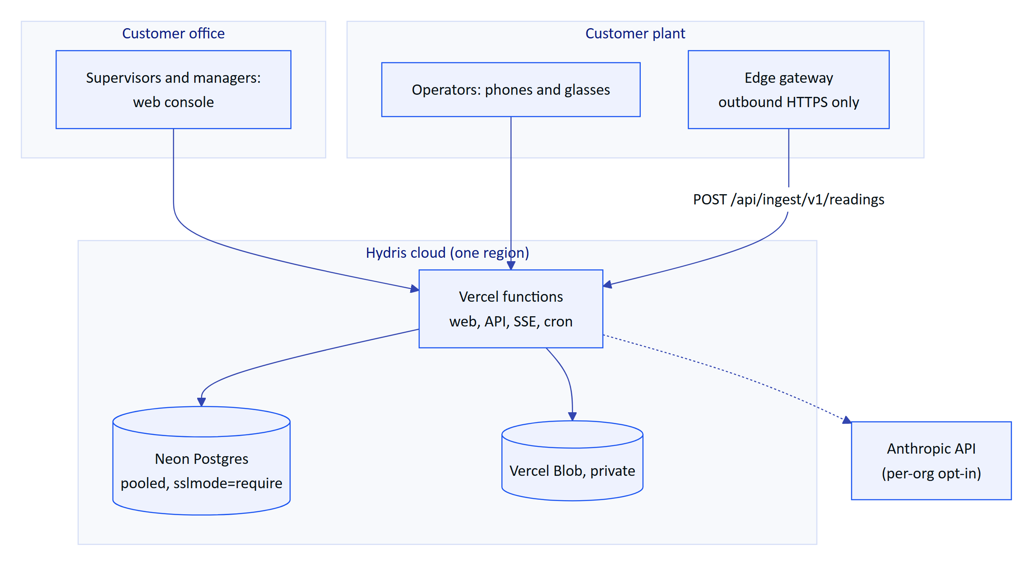
Figure 4. Topology A, managed SaaS: Vercel functions with Neon Postgres and private Blob storage
Table 2. Current infrastructure capability status
Setting | Value
Vercel plan | Pro (Hobby is limited to non-commercial use and daily crons)
Function region | Same region as the database (one region per deployment)
Database | Neon Postgres, pooled connection string, sslmode=require
Connections | 3 per function instance (poolMax: config.serverless ? 3 : 10 in serverless.ts)
Realtime | REALTIME_MODE=db
Attachments | Private Blob store (BLOB_READ_WRITE_TOKEN)
Cron | /api/cron every minute (requires Vercel Pro)
Tenancy | Many organizations per database, isolated by RLS

Topology A suits customers without strict residency requirements, and customers whose residency needs are met by an India region (see below). Its main limits are function duration (60 seconds), per-instance rate limiting and polling-based realtime with up to about 1.5 seconds of latency (docs/operations/vercel.md).

3.2 Topology A-IN: India region
Topology A deployed with every data-bearing component in India. The application code is identical; the differences are region choices and subprocessor configuration.
Table 3. Topology A configuration
Component | India option | Notes
Functions | Vercel region bom1 (Mumbai) | Set in Project, Settings, Functions. Static assets are still served from the global edge network
Database | Neon in an India region if offered, otherwise AWS RDS or Aurora Postgres in ap-south-1 (Mumbai) or ap-south-2 (Hyderabad) | Confirm Neon region availability at contract time
Object storage | AWS S3 in ap-south-1 behind the Storage interface | Vercel Blob region control must be confirmed; S3 is the safe default
Logs | Log drain to a store in India | Needed for CERT-In 180-day log retention in Indian jurisdiction
AI processing | Off by default for strict-residency tenants | Anthropic processing location is outside India; see HFG-SEC
Backups | Same region plus a second Indian region | Mumbai primary, Hyderabad secondary

DECISION
For Indian public-sector and municipal customers the default is Topology A-IN with AI features switched off until the customer signs an explicit addendum covering processing outside India. This keeps the default deployment inside India without forking the product.

3.3 Topology B: Vercel web with a container API
For larger tenants, long-lived SSE connections, or where background jobs must run every few seconds, the API runs as a long-lived container and the web build proxies /api to it by setting API_URL. The container entry point is apps/api/src/server.ts, which starts the timer-driven jobs in startJobs (stale rules every 30 seconds, pairing expiry every 60 seconds, realtime pruning every hour in db mode).
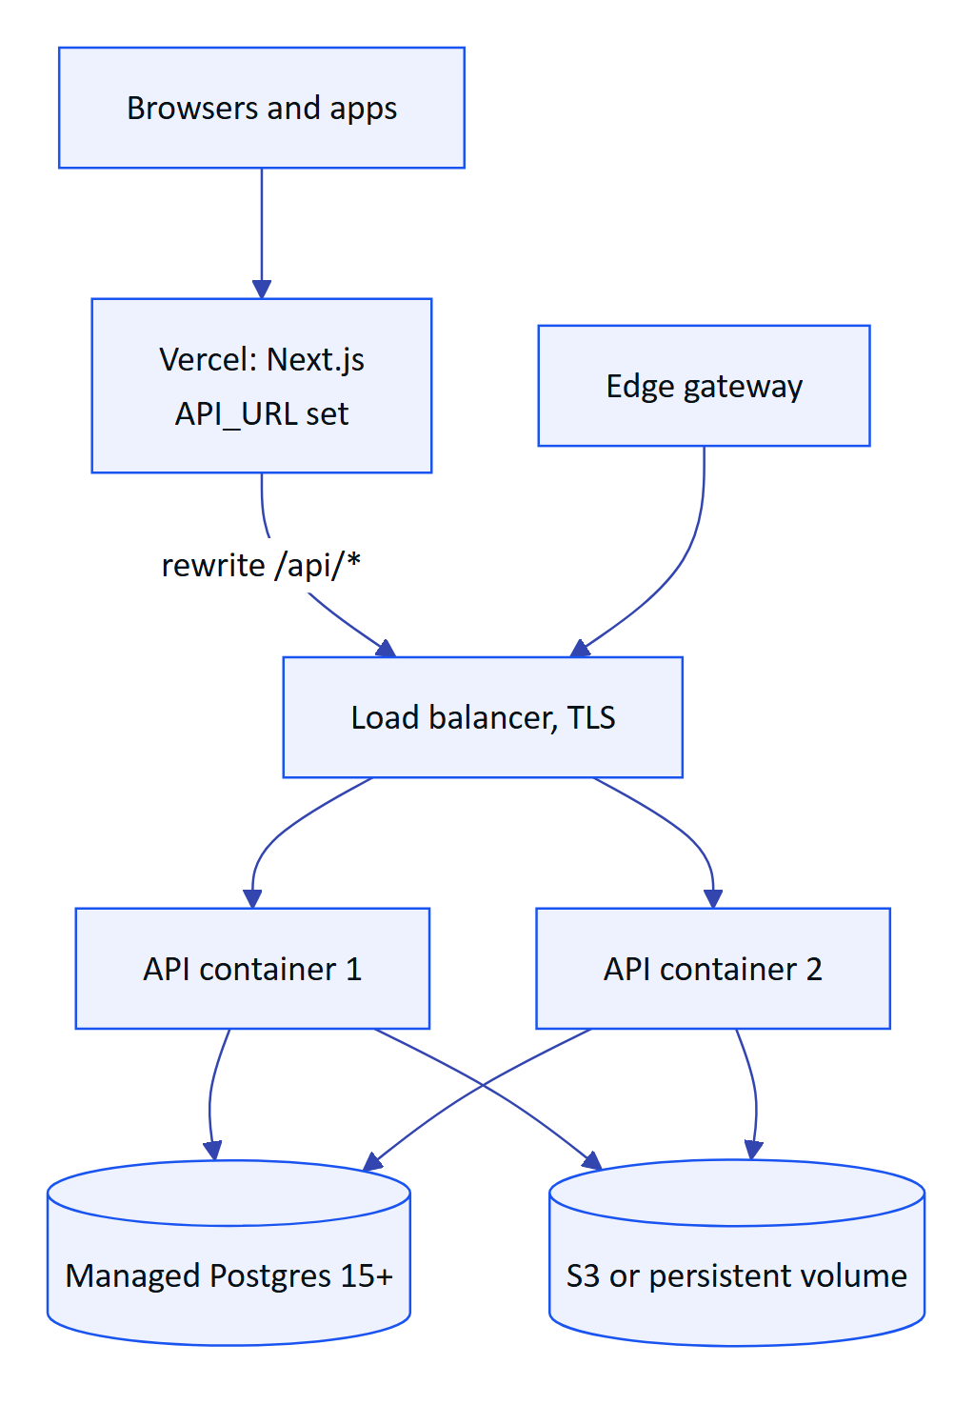
Figure 5. Topology B, Vercel web with an API container on Render, Fly.io or AWS ECS
The render.yaml blueprint is a ready starting point: a Docker web service with healthCheckPath: /api/health, a 5 GB disk mounted at /data/files, SIMULATOR_ENABLED=false and a generated JWT_SECRET. Two changes are required before running more than one container: set REALTIME_MODE=db (the in-memory bus is per process) and replace disk storage with S3-compatible object storage, because a disk volume cannot be shared between replicas.

3.4 Topology C: on-premises or plant-edge install
Some plants, especially those under strict OT security policies, cannot send data to a public cloud at all. For them Hydris runs on a server inside the plant network using docker-compose.yml (Postgres 17, API, web). The phones and the glasses bridge connect over the plant Wi-Fi to a local hostname. Nothing leaves the site.
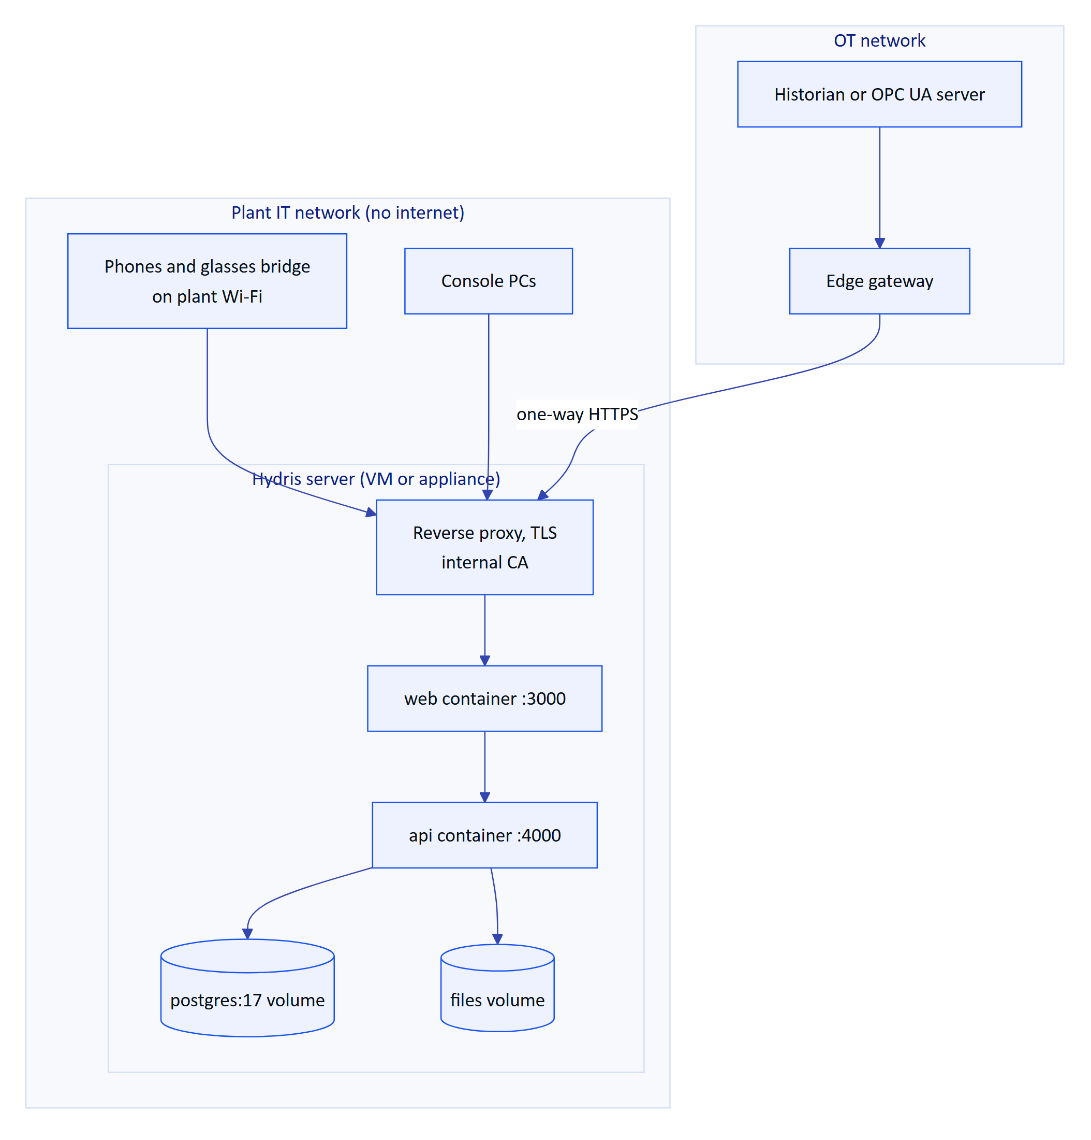
Figure 6. Topology C, air-gapped plant install: everything on one server inside the plant network
Table 4. India region component choices
Concern | Air-gapped approach | Status
Install | Versioned container images delivered as a signed archive, loaded with docker load | Planned
TLS | Reverse proxy (Caddy or nginx) with a certificate from the plant's internal CA | Planned
Updates | Quarterly offline bundles with migration notes; migrations run on API start (server.ts) | Partial
AI features | Disabled (no ANTHROPIC_API_KEY); rules-based assistant and on-device OCR remain | Built (automatic fallback)
Android apps | Installed from the customer MDM with hydris_url pointing at the local hostname | Partial (hydris_url is a build-time property today)
Meta glasses | DAT needs the Meta AI app, which needs internet at registration time | Constraint: confirm with Meta before quoting air-gapped glasses
Backups | Nightly pg_dump to a plant NAS plus a weekly offline copy | Planned
Support access | Escorted remote session on request; no standing vendor access | Policy

RISK
The Ray-Ban Meta glasses depend on the Meta AI companion app and Meta's Wearables Device Access Toolkit. A fully air-gapped plant may therefore support the phone apps and console but not the glasses. This must be stated in the proposal, not discovered at commissioning.

3.5 Topology D: hybrid with an edge gateway
The common case for industrial customers: the application runs in the cloud (A or A-IN) and a small gateway in the plant pushes telemetry outward. The gateway reads from the historian, PLC data server or OPC UA endpoint on the OT side and posts batches of up to 500 readings to POST /api/ingest/v1/readings with a gateway key (hgw_ prefix, stored only as a SHA-256 hash in gateways.key_hash; apps/api/src/modules/telemetry.ts). Hydris never connects into the plant.
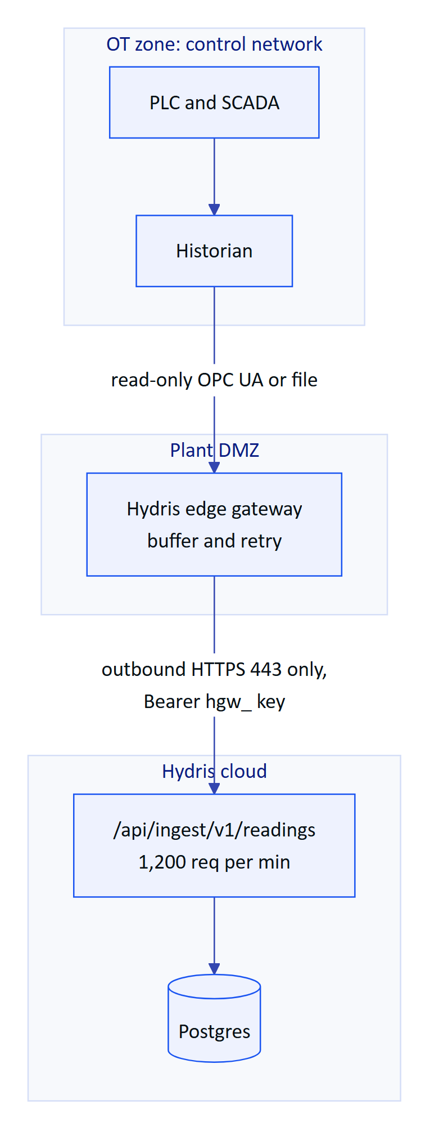
Figure 7. Topology D, hybrid: an edge gateway pushes telemetry outward through the plant DMZ
The ingest endpoint is idempotent per sensor and timestamp (unique (sensor, ts) index) and accepts an optional messageId, so the gateway can retry safely after a network outage. The gateway itself (store-and-forward software, hardware choice, OPC UA client) is Planned; the API contract it targets is Built.

3.6 Choosing a topology
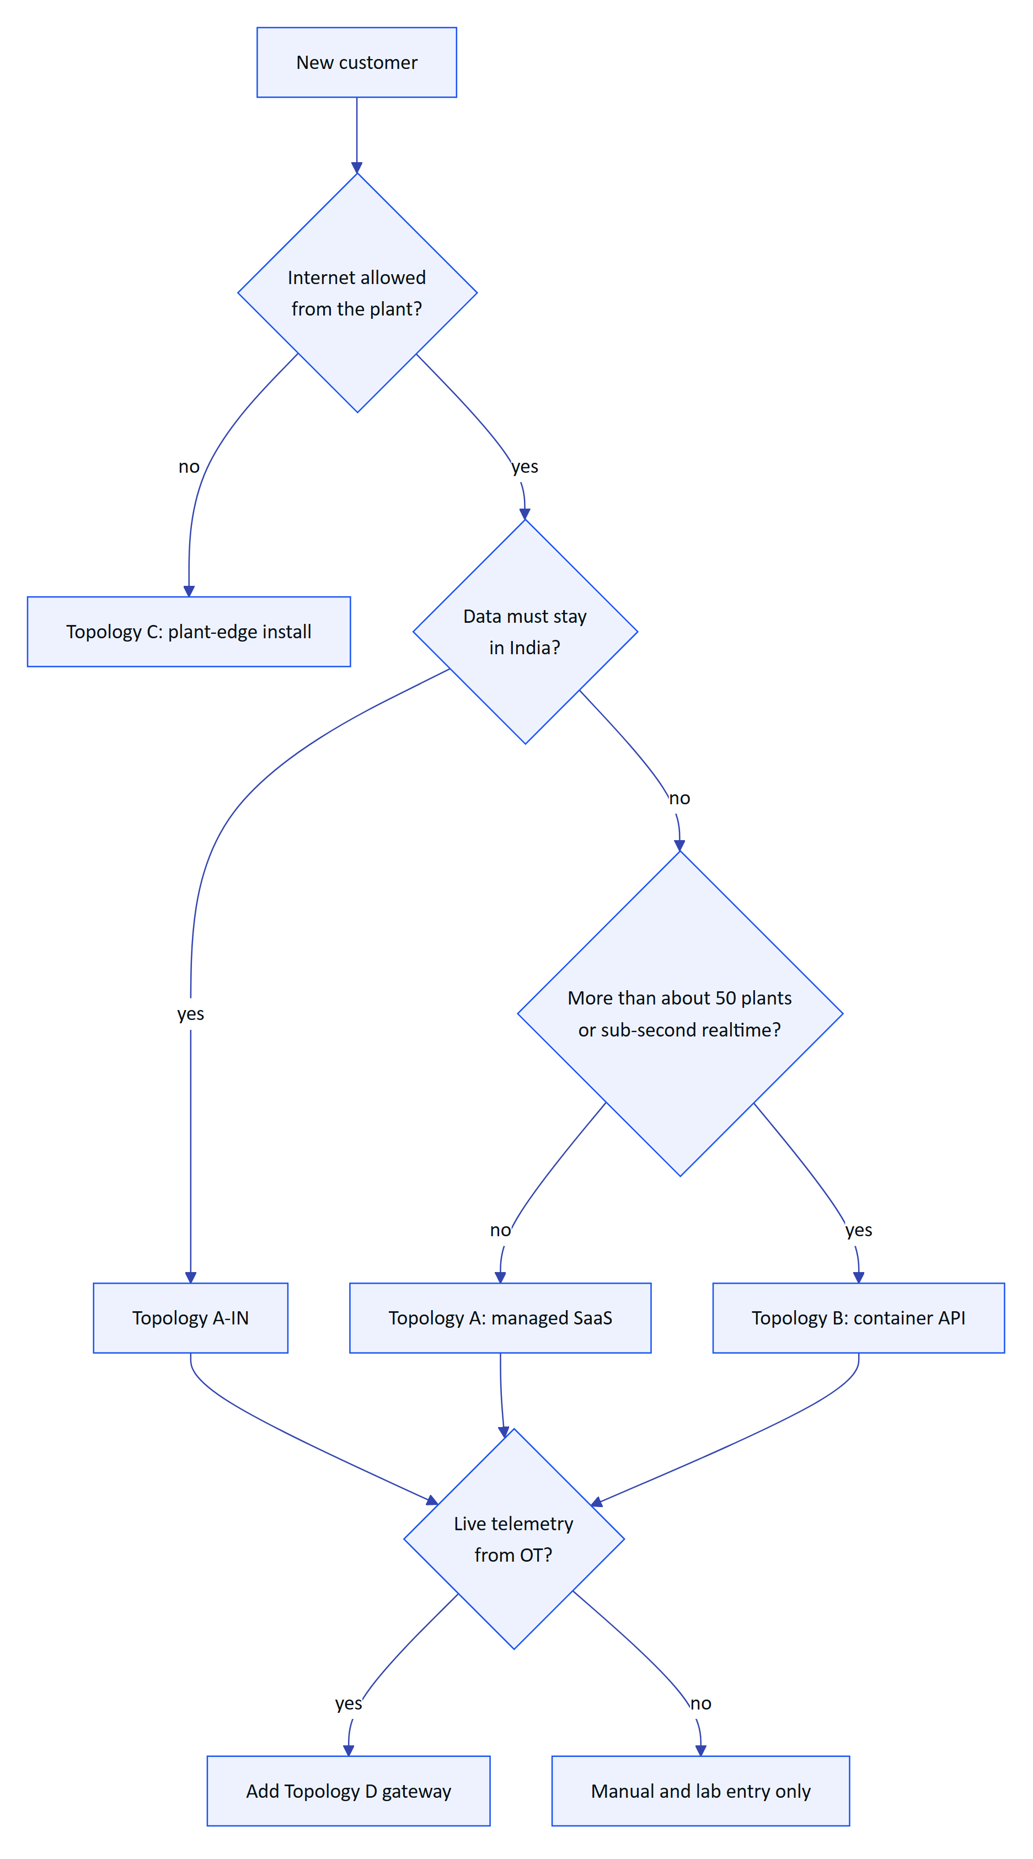
Figure 8. Topology selection for a new customer
Table 5. Plant-edge install considerations
Topology | Best for | Data location | Ops burden | AI features | Glasses | Status
A | Pilots, private industry | Chosen cloud region | Low (Hydris) | Opt-in | Yes | Partial (needs prod DB and cron fix)
A-IN | Indian PSUs, municipal STPs | India | Low (Hydris) | Off by default | Yes | Planned
B | Large multi-plant groups | Chosen region | Medium (Hydris) | Opt-in | Yes | Planned (artefacts built)
C | Air-gapped plants | Customer premises | High (shared) | Off | Phone yes, glasses to confirm | Planned (compose built)
D | Any customer with online instruments | Gateway in plant, data in A, A-IN or B | Medium (shared) | n/a | n/a | Planned (API built)

4 Environment matrix
Hydris uses five environments. They differ in data, secrets, who can reach them and which mobile builds point at them. Demo is deliberately separate from staging: a demo is a sales tool and resets itself, staging is a release gate.
Table 6. Topology comparison
Environment | Purpose | URL | Database | Secrets | Simulator | Mobile builds | Status
dev | Local development (npm run dev) | localhost:3000, API on :4000 | PGlite at ./data/pglite | Local .env | On | Debug APKs with hydris_url set locally | Built
preview | One per pull request | Vercel preview URL | Neon branch per preview (target) or demo mode | Preview scope in Vercel | On | None | Partial (demo mode today)
staging | Release candidate, hardware tests, pilot rehearsal | staging. subdomain (target) | Neon staging branch, seeded demo tenant | Staging scope | On for demo tenant only | Play internal track, DAT test channel | Planned
prod | Customer tenants | Customer-facing domain | Neon production, region pinned, PITR on | Production scope, managed secrets | Off (false) | Play closed track or MDM | Planned
demo | Public sales demo | hydrisview.vercel.app | In-memory PGlite per instance | Public demo secrets | On | Debug builds for demos | Built

Today main deploys straight to the demo URL. The target separates them into two Vercel projects pointing at the same repository: a demo project that tracks main with no DATABASE_URL, and a production project that deploys only on release tags after the staging gate. This keeps sales demos current without coupling them to customer releases.
TIP
Neon branches make per-preview databases cheap: each preview deployment gets a copy-on-write branch of the staging database, migrations run against it on the first request, and the branch is deleted when the pull request closes. This is the single biggest improvement to review quality we can make cheaply.

5 Configuration reference
All server configuration is read from environment variables. apps/api/src/config.ts validates the core set with zod and refuses to start on invalid values; a handful of operational variables are read directly with process.env elsewhere. In development the API also loads .env from the repository root or the working directory with process.loadEnvFile.

5.1 Variables validated by config.ts
Table 7. Environment matrix
Variable | Required | Default | Validation | Purpose
NODE_ENV | No | development | development, test or production | production sets isProd, which marks refresh cookies Secure
API_PORT | No | 4000 | integer | Listen port for the container server
HOST | No | 127.0.0.1 | string | Listen address; set 0.0.0.0 in containers
DATABASE_URL | Yes in prod | ./data/pglite | string | postgres://... for Postgres, a directory path for PGlite, or memory://
JWT_SECRET | Yes | demo value in demo mode | at least 32 characters | Signs every JWT (user, device, MFA challenge, demo session)
DATA_KEY | Yes | demo value in demo mode | exactly 64 hex characters | AES-256-GCM key for MFA secrets at rest
PUBLIC_APP_URL | Yes in prod | http://localhost:3000 | URL | Base of pairing, invitation and reset links
STORAGE_DIR | Containers | ./data/files | string | Disk storage for attachments when Blob is not configured
SEED_ADMIN_EMAIL | Seed only | none | optional | First platform admin for apps/api/src/seed/cli.ts
SEED_ADMIN_PASSWORD | Seed only | none | optional | Its password (12+ characters)
SEED_DEMO_PASSWORD | Seed only | none | optional | Password for seeded demo role accounts
SIMULATOR_ENABLED | No | true | true or false | Enables the demo-tenant simulator; false in production
REALTIME_MODE | No | memory | memory or db | db is required on serverless or with more than one instance
BLOB_READ_WRITE_TOKEN | On Vercel | none | optional | Switches attachments to a private Vercel Blob store
CRON_SECRET | On Vercel | none | optional | Bearer secret required by /api/cron
SERVERLESS | No | none | 1 or true | Forces serverless behaviour (no interval timers)
VERCEL | Auto | set by Vercel | optional | Detects Vercel: serverless behaviour and demo auto-detection
DEMO_MODE | No | auto | true or false | Forces demo mode on or off

5.2 Variables read directly from the environment
Table 8. Configuration validated by apps/api/src/config.ts
Variable | Read in | Purpose
DEMO_PERSIST | config.ts (demoDefaults) | With DEMO_MODE and a Postgres URL, seeds the demo into that database instead of memory
ANTHROPIC_API_KEY | core/vision-extract.ts (visionAvailable) | Enables Claude vision extraction for audit scans and the Claude engine of the voice assistant
ANTHROPIC_AUTH_TOKEN | core/vision-extract.ts | Alternative Anthropic credential; either one enables the AI features
MIGRATE_ON_START | serverless.ts | false skips cold-start migrations (when npm run vercel-build runs them)
HYDRIS_MIGRATIONS_DIR | serverless.ts (findMigrationsFolder) | Overrides where the bundle looks for drizzle/meta/_journal.json
API_LOG | serverless.ts | true enables Fastify request logging at info level
API_URL | apps/web/next.config.ts | Switches the web build to proxy /api to an external API
VERCEL_PROJECT_PRODUCTION_URL, VERCEL_URL | config.ts | Demo mode only: derives PUBLIC_APP_URL
POSTGRES_PASSWORD | docker-compose.yml | Password for the compose database owner

5.3 Android build properties
The Android apps are configured at build time through local.properties (not committed), read in each app/build.gradle.kts:
Table 9. Operational variables outside the zod schema
Property | App | Default | Purpose
hydris_url | both | https://hydrisview.vercel.app | Server the app talks to (BuildConfig.HYDRIS_URL)
mwdat_application_id | both | 0 | Meta Wearables application ID (0 in DAT Developer Mode)
mwdat_client_token | both | 0 | Meta Wearables client token
sdk.dir | both | none | Android SDK path

WARNING
Because hydris_url is compiled in, a customer on Topology A-IN, B or C needs a separate build today. The target is an MDM managed-configuration key (hydris_url) read at run time, with the build value as fallback, so one signed APK serves every customer.

5.4 Secrets handling rules
- Generate JWT_SECRET, DATA_KEY and CRON_SECRET with 32 random bytes each (node -e "console.log(require('crypto').randomBytes(32).toString('hex'))").
- Store them only in the Vercel project's environment variables (production scope separate from preview), or in the cloud provider's secrets manager for containers. Never in the repository, never in NEXT_PUBLIC_*.
- DATA_KEY is not rotatable without re-encrypting every users.mfa_secret_enc value. Losing it disables MFA for every user. Keep an offline escrow copy under two-person control.
- Rotating JWT_SECRET signs everyone out (all access tokens and the MFA step become invalid; refresh cookies remain valid because they are random tokens checked against hashes). It also changes the salt used for the hashed IP on website inquiries (modules/public.ts).
- Preview deployments must not share production secrets or the production database.

6 Build and release pipeline

6.1 How a release happens today
There is no CI. A merge or push to main triggers Vercel's Git integration, which installs, builds and deploys. Tests and type checks are run by developers locally (npm test, npm run typecheck, npm run test:e2e). The Android apps are built from Android Studio or Gradle on a developer machine and installed with adb.
Table 10. Android build-time properties
Step | Command | Where defined | Notes
Install | npm ci --include=dev | root vercel.json | Dev dependencies are needed for the TypeScript build
Build | npm run build (runs npm run build -w @hydris/web) | root package.json | API is compiled into the web build via transpilePackages
Migrate | On first request per instance, or npm run vercel-build | serverless.ts, root package.json | Advisory lock key 4872917633
Seed | npx tsx apps/api/src/seed/cli.ts [--demo] from an operator machine | docs/operations/vercel.md | Creates the platform admin; safe to rerun

The weaknesses are clear: a type error or failing test can reach production, and a migration can run in production before anyone has run it against realistic data. Vercel's instant rollback protects the web tier but not the database.

6.2 Release versioning
Table 11. Current build and release steps
Artefact | Version source | Target scheme
Web and API | root package.json version (0.2.0) | Semantic version tag vX.Y.Z on main; tag triggers production
Database schema | Drizzle journal apps/api/drizzle/meta/_journal.json | Monotonic migration index, never edited after release
Hydris Field app | versionCode = 1, versionName = "1.0.0" | versionCode from the CI run number, versionName from the tag
Glasses bridge | versionCode = 1 | Same as above

6.3 Release train
Table 12. Versioning of release artefacts
Cadence | What ships | Gate
Continuous | Web and API fixes behind no flag | CI green, one reviewer
Fortnightly | Features, migrations | CI green, staging soak 48 hours, release notes
Monthly | Android apps to the pilot track | Staging hardware test on real glasses
Quarterly | Offline bundle for Topology C | Signed archive, upgrade rehearsal

7 Proposed CI/CD with GitHub Actions
The pipeline below is Planned. It uses only commands that already exist in the repository's package.json scripts and Gradle wrappers, so it can be added without code changes.

7.1 Pipeline design
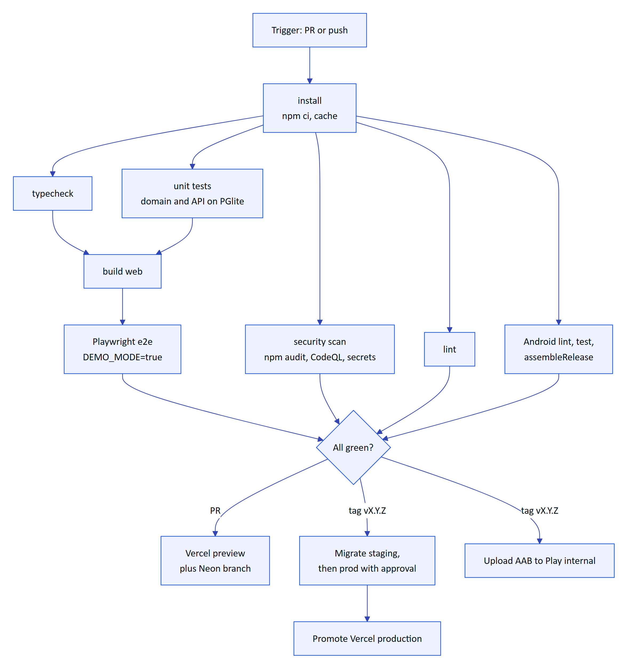
Figure 9. Proposed GitHub Actions workflow: jobs and gates
Table 13. Target release cadence
Job | Runs | Commands | Blocks merge | Target time
install | Every PR and push | npm ci with npm cache keyed on package-lock.json | Yes | 1 min
typecheck | Every PR | npm run typecheck | Yes | 2 min
lint | Every PR | npm run lint | Yes | 1 min
unit | Every PR | npm test (domain, then API against PGlite) | Yes | 3 min
build | Every PR | npm run build | Yes | 4 min
e2e | Every PR | npx playwright install chromium, npm run test:e2e against a demo-mode server | Yes | 6 min
security | Every PR, nightly | npm audit --omit=dev --audit-level=high, CodeQL, secret scanning | High and critical only | 5 min
android | PRs touching apps/android*, tags | ./gradlew lint testDebugUnitTest assembleRelease in both apps | Yes | 8 min
migrate | Tags | npm run db:migrate against staging, then production after approval | n/a | 1 min
deploy | Tags | vercel deploy --prebuilt --prod or promote the staging deployment | n/a | 3 min
publish-android | Tags | Sign with upload key, upload AAB to Play internal track | n/a | 4 min

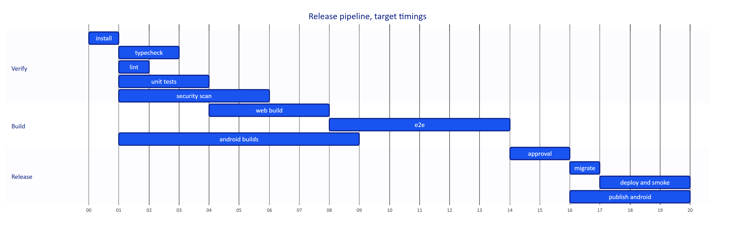
Figure 10. Target duration of the pipeline stages for a release tag (minutes from start)

7.2 Example workflow
# .github/workflows/ci.yml (proposed)
name: ci
on:
pull_request:
push:
branches: [main]
tags: ['v*']
jobs:
verify:
runs-on: ubuntu-latest
steps:
- uses: actions/checkout@v4
- uses: actions/setup-node@v4
with: { node-version: 22, cache: npm }
- run: npm ci
- run: npm run typecheck
- run: npm test
- run: npm run build
e2e:
needs: verify
runs-on: ubuntu-latest
env: { DEMO_MODE: 'true' }
steps:
- uses: actions/checkout@v4
- uses: actions/setup-node@v4
with: { node-version: 22, cache: npm }
- run: npm ci
- run: npx playwright install --with-deps chromium
- run: npm run test:e2e
android:
runs-on: ubuntu-latest
strategy:
matrix: { app: [apps/android, apps/glasses-bridge-android] }
steps:
- uses: actions/checkout@v4
- uses: actions/setup-java@v4
with: { distribution: temurin, java-version: 21 }
- run: ./gradlew lint testDebugUnitTest assembleRelease
working-directory: ${{ matrix.app }}

7.3 Gates and policies
Table 14. Proposed CI jobs
Gate | Rule
Branch protection | main requires a pull request, one approving review and all required checks
Migrations | Any change under apps/api/drizzle/ needs a second reviewer from platform engineering
Secrets | Production secrets live in a GitHub environment production with required reviewers
Dependencies | Renovate or Dependabot weekly; lockfile changes go through CI like code
Provenance | Release tags signed; build logs retained 90 days
Smoke test | After deploy, /api/health returns ok and a scripted login and alarm list succeed
Automatic rollback | If the smoke test fails, promote the previous Vercel deployment (schema permitting, see below)

NOTE
playwright.config.ts starts npm run dev as its web server. In CI the e2e job should start a production build in demo mode instead (next start with DEMO_MODE=true) so the tests exercise the same code path as Vercel. The comment in the config already anticipates CI use.

8 Database migrations and rollback

8.1 How migrations run
Migrations are plain SQL files generated by Drizzle Kit (npm run db:generate) and stored in apps/api/drizzle/ with a journal in meta/_journal.json. There are nine today: the base schema (0000_init), row-level security (0001_rls), corrections and UI profiles (0002), RLS for those tables (0003), role membership for managed Postgres (0004), the realtime event log (0005, 0006) and audit documents (0007, 0008).
On Postgres, createDatabase().migrate in apps/api/src/db/client.ts takes a dedicated connection, acquires a session-level advisory lock (pg_advisory_lock(4872917633)), runs Drizzle's migrator and releases the lock. This serializes concurrent migrators: several serverless instances cold-starting together, or a deploy step racing a running instance.
Table 15. Release gates
Mode | How | When to use
Cold start (default) | migrate() in serverless.ts unless MIGRATE_ON_START=false | Demo, small pilots
Build step | npm run vercel-build runs db:migrate then build; set MIGRATE_ON_START=false | Topology A production
Pipeline step | CI migrate job before promotion | Target for all production deploys
Container start | server.ts migrates on boot (Dockerfile comment) | Topologies B and C

WARNING
Running migrations in the Vercel build step means a migration is applied before the new deployment is promoted, and is not undone if the build later fails. That is safe only if every migration is backward compatible with the code currently in production. The expand and contract rule below makes that true.

8.2 Managed Postgres prerequisites
Migration 0001_rls.sql creates the NOLOGIN role hydris_app, grants it table privileges, revokes UPDATE and DELETE on audit_events, and enables and forces RLS on every tenant table. Migration 0004 grants hydris_app to the connecting user WITH SET TRUE so the application can SET LOCAL ROLE hydris_app (needed on Postgres 16 and later). If the provider forbids it, an administrator runs once: GRANT hydris_app TO <app_user> WITH SET TRUE; (docs/operations/vercel.md).
The comment in 0001_rls.sql is important for production: owner and superuser connections bypass RLS, so the application must always switch to hydris_app, which withTenant and withSystem in apps/api/src/db/tenant.ts do for every transaction. The target is a separate migration user (owner) and runtime user (member of hydris_app, no ownership), so a code path that forgets to switch role still cannot bypass RLS.

8.3 Expand and contract
Every schema change ships in two releases so that the old and new application versions both work against the schema in between.
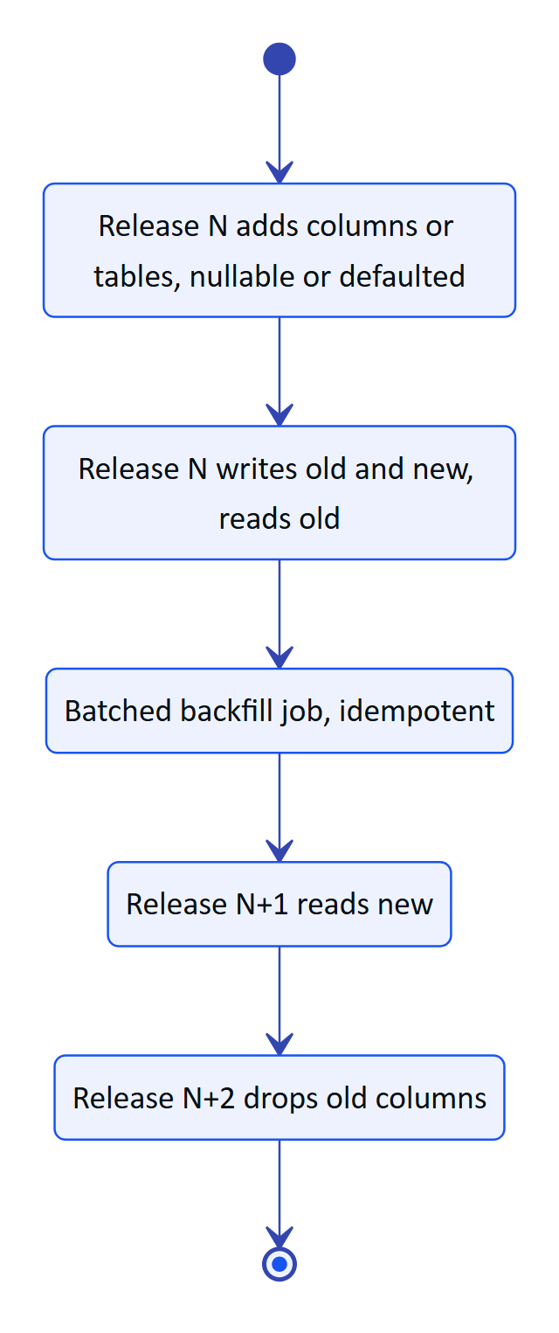
Figure 11. Expand and contract keeps every deployment rollback-safe
Table 16. Migration execution modes
Change | Allowed in one release | Needs expand and contract
Add table, add nullable column, add index concurrently | Yes | No
Add NOT NULL column with default | Yes on Postgres 11+ | No
Rename column or table | No | Yes (add, dual write, switch, drop)
Change column type | No | Yes
Drop column or table | No | Yes, only after no deployed code reads it
New RLS policy on a new table | Yes, in the same migration as the table | No
Tighten an existing RLS policy | Review required | Test against staging data first

8.4 Rollback
Table 17. Migration safety rules
Situation | Action | Data impact
Bad web or API code, schema unchanged | Vercel instant rollback to the previous deployment | None
Bad code after an expand migration | Roll back code; leave the additive schema in place | None
Bad migration caught on staging | Fix forward with a new migration; never edit a released migration file | None
Bad migration in production, data intact | Write a forward migration that reverses it; deploy through the normal pipeline | None
Migration corrupted or deleted data | Neon point-in-time restore to a branch just before the migration, verify, then switch DATABASE_URL or copy rows back | Writes after the restore point must be replayed or accepted as lost

Drizzle migrations are forward-only. We do not write down migrations; the fix for a bad migration is another migration. Point-in-time restore is the last resort and is rehearsed quarterly (see backup and disaster recovery).

9 Background jobs and scheduling

9.1 Jobs that exist
apps/api/src/jobs.ts defines one pass of every background job in runScheduledJobs, and a timer-driven version for long-running servers in startJobs.
Table 18. Rollback playbook
Job | Function | Container interval (startJobs) | Serverless trigger | Status
Stale-data alarms | evaluateStaleRules (modules/alarms.ts) | 30 s | /api/cron | Built
Pairing expiry | expirePairings | 60 s | /api/cron | Built
Realtime log pruning (1 day) | pruneRealtimeEvents (core/events.ts) | 1 h in db mode | /api/cron | Built
Demo simulation steps | SimulationEngine.advanceAll | continuous | /api/cron, and lazily on requests in demo mode (DemoTicker) | Built
Resume running simulations after restart | in startJobs | on boot | n/a | Built
Expired session and pairing purge | none | none | none | Planned
Mail delivery from mail_outbox | none | none | none | Planned
Retention and archival | none | none | none | Planned
Audit page image migration to object storage | none | none | none | Planned

Each job is wrapped in its own catch, so one failure is reported in the JSON (staleRules: "error: ...") and does not stop the others. That JSON report is the only job telemetry today.

9.2 The daily cron problem
The root vercel.json schedules /api/cron once a day at 03:00 UTC. On Vercel, stale-data alarms ("no reading for 15 minutes") therefore fire up to 24 hours late, and expired pairing challenges are only marked expired once a day (pairing codes are still rejected when used after their 300-second TTL, because the poll and approve paths check expiresAt).
CAUTION
Stale-data alarms are a safety-relevant feature for operators: a silent instrument looks like a healthy one. Before any customer pilot on Topology A, change the schedule to * * * * * on Vercel Pro, or run the jobs from an external scheduler, or use Topology B. This is the first item on the go-live checklist.

Table 19. Background jobs
Option | Frequency | Cost | Trade-off
Vercel Pro cron * * * * * | 1 min | Included in Pro | Simplest; one invocation per minute
External scheduler (GitHub Actions schedule, cron-job.org, cloud scheduler) calling /api/cron | 1 to 5 min | Low | Another moving part; GitHub schedules can drift by minutes
Topology B container | 30 to 60 s | Container cost | Best freshness; more operations

9.3 Job design rules for new jobs
- Every job is idempotent and safe to run concurrently on two instances (use UPDATE ... WHERE predicates or advisory locks, as the migration code does).
- Every job runs through withSystem so RLS and append-only grants still apply.
- Batch large work (purges, backfills) into chunks under 10 seconds so a 60-second function limit is never hit.
- Report counts in the cron JSON and emit a metric per job (see observability).

10 Android app distribution
Hydris ships two Android apps. Hydris Field (apps/android, ai.hydris.field) is the native operator app with camera capture, on-device ML Kit OCR and the Meta DAT integration. The Glasses bridge (apps/glasses-bridge-android, ai.hydris.glassesbridge) hosts the /glasses web app in a WebView and connects the Ray-Ban Meta camera, capture button and microphone through DAT 1.0.1. Both target SDK 36 with a minimum of SDK 31 (Android 12), matching Meta's DAT requirement.

10.1 Distribution channels
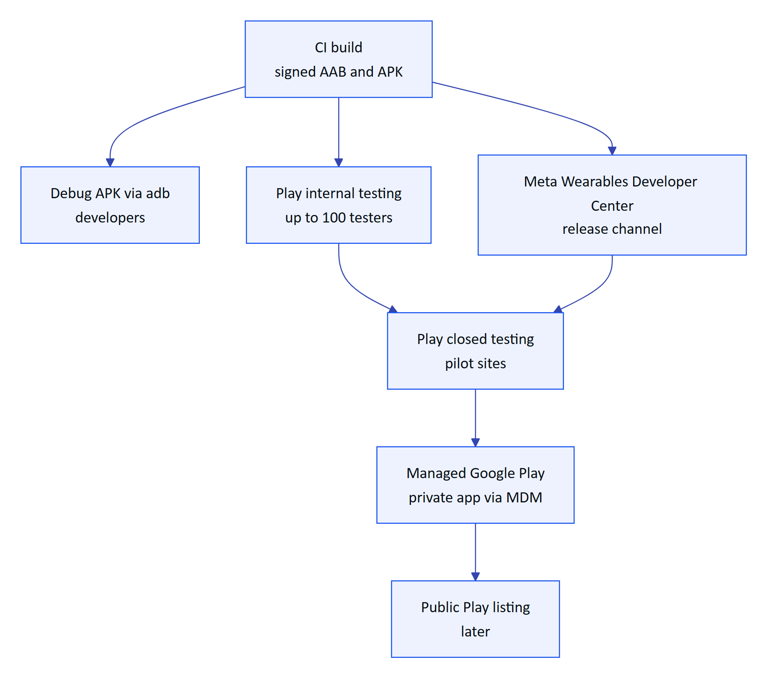
Figure 12. Android distribution channels by stage
Table 20. Options for job frequency on Vercel
Channel | Audience | DAT requirement | Use | Status
Debug APK with adb | Hydris developers | Developer Mode in the Meta AI app (IDs 0/0) | Daily development | Built (a debug APK is checked in at apps/glasses-bridge-android/hydris-glasses-debug.apk)
Play internal testing | Up to 100 named testers | Developer Mode until the app is registered | Pilot rehearsals, staging | Planned
Meta Wearables Developer Center release channel | Named DAT testers who are not developers | Registered app ID and client token | Glasses features for pilot users | Planned
Play closed testing | Pilot plant staff | Registered app | Pilot | Planned
Managed Google Play private app | Enterprise fleets via MDM (Intune, Workspace ONE, Knox) | Registered app | Commercial rollout | Planned
Public Play listing | General availability | Meta publishing approval | Later | Planned

NOTE
A debug APK is committed to the repository. Remove it from version control and attach builds to CI artefacts or releases instead; binaries in Git bloat the repository and cannot be traced to a commit reliably.

10.2 Signing keys
Table 21. Android distribution channels
Key | Purpose | Holder | Storage | Status
Debug key | Local builds | Each developer | Android SDK default | Built
Upload key | Signs AABs uploaded to Play | CI | GitHub environment secret (base64 keystore plus passwords), offline backup under two-person control | Planned
App signing key | Signs APKs delivered to devices | Google (Play App Signing) | Google-managed | Planned
Enterprise sideload key | Signs APKs for air-gapped MDM without Play | Hydris release manager | HSM or offline vault | Planned (Topology C only)
Meta DAT credentials | mwdat_application_id, mwdat_client_token | CI | GitHub environment secret, injected into local.properties at build | Planned

CAUTION
apps/android/app/build.gradle.kts currently signs the release build type with the debug key (signingConfig = signingConfigs.getByName("debug"), with a comment to replace it). A release signed with a debug key cannot be uploaded to Play and must never be distributed to customers. Configure the upload key from CI secrets before the first pilot build.

10.3 Enterprise MDM configuration
Table 22. Android signing and credential inventory
Managed configuration key | Type | Purpose | Status
hydris_url | string | Server URL for this customer (A, A-IN, B or C) | Planned
org_hint | string | Pre-selects the organization on the sign-in screen | Planned
allow_ai_features | boolean | Hides AI-assisted extraction where the org has opted out | Planned
kiosk_mode | boolean | Device-owner mode for shared phones at a plant | Planned

Shared phones (one phone per shift, not per person) are common in plants. The app already encrypts credentials with an Android Keystore key and disables backup (android:allowBackup="false" in both manifests), so a shared device does not leak the previous user's session to a backup. Sign-out on shift change is a process requirement documented in the Operations Runbook.

11 Observability

11.1 Current state
Table 23. Proposed MDM managed configuration
Signal | Today | Where
Logs | Vercel function logs; Fastify logs only when API_LOG=true; 5xx errors logged by the error handler; route handlers log start failures | serverless.ts, app.ts, route.ts
Health | GET /api/health returns ok and server time | apps/api/src/app.ts
Job results | JSON report from /api/cron | apps/web/src/app/api/cron/route.ts
Business signals | Audit events and alarm history in the database | audit_events, alarm_event_history
Metrics, traces, error tracking, uptime | None | Planned

/api/health does not touch the database, so it reports the function as up even when Postgres is unreachable. A deep health check (/api/health?deep=1 running select 1 and checking the migration journal) is Planned.

11.2 Target architecture
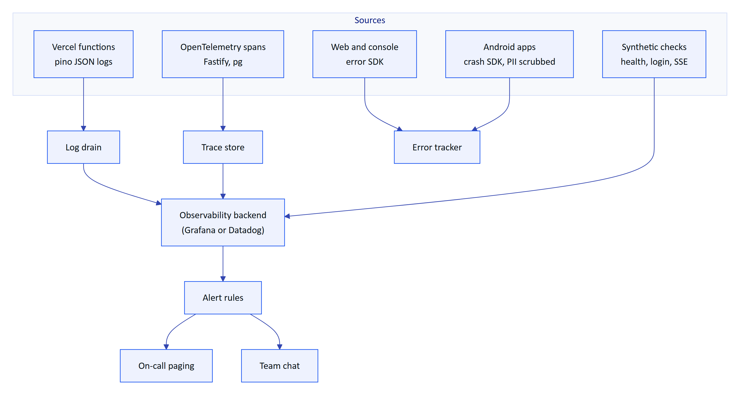
Figure 13. Target observability pipeline
Table 24. Observability today
Signal | Tooling (proposed) | Content | Residency note
Logs | Vercel log drain to Grafana Loki, Datadog or an India-hosted store | Structured JSON with request id, org id, route, status, duration; no tokens, no bodies | CERT-In requires 180 days of logs in India for Indian service providers
Metrics | OpenTelemetry metrics or log-derived metrics | Request rate, error rate, latency, cold starts, DB pool waits, job counts
Traces | OpenTelemetry for Fastify and pg | Span per request and per query | Sample 10% in production
Errors | Sentry (or equivalent) for web, console and Android | Stack traces with PII scrubbing and IP anonymisation | Choose EU or self-hosted for strict tenants
Uptime | External synthetic checks every minute | /api/health, login, SSE connect, cron freshness

11.3 Key metrics
Table 25. Target observability stack
Metric | Why it matters | Alert threshold (target)
API 5xx rate | Overall health | Over 1% for 5 min
p95 API latency | Console and glasses responsiveness | Over 800 ms for 10 min
Ingest lag (now minus newest reading per gateway) | Live telemetry is the core promise | Over 5 min for any active gateway
Cron last success age | Stale alarms depend on it | Over 3 min (after the per-minute fix)
SSE reconnect rate | Realtime health | Over 3 per client per 5 min
auth.login_failed rate | Credential stuffing | 10x baseline
auth.refresh_reuse_detected, device.refresh_reuse_detected | Token theft | Any occurrence
Postgres connections in use | Pool exhaustion with many instances | Over 80% of the pooler limit
Anthropic error rate | AI features degrade to rules engine | Over 20% for 15 min

11.4 Service level objectives
SLOs are targets for the pilot and the first commercial year. They are not measured results.
Table 26. Key metrics and alert thresholds
SLI | SLO target | Window | Error budget
Availability of /api/* (non-5xx, excluding 429) | 99.5% | 30 days | 3.6 hours
Latency: p95 of read API calls | Under 500 ms | 30 days | 5% of requests may exceed
Telemetry freshness: readings visible within 60 s of ingest | 99% | 30 days | 1% of readings
Stale-data alarm raised within 2 min of the configured threshold | 99% | 30 days | 1% of evaluations
Realtime delivery: event visible on an open console within 5 s | 99% | 30 days | 1% of events
Audit scan upload success | 99% | 30 days | 1% of uploads
Cron success | 99.9% of runs | 30 days | about 43 failed runs at 1 per min

Error budget policy: while less than half of the monthly budget is consumed, releases proceed normally. Between half and all of it, risky changes need approval from the platform lead. Once the budget is exhausted, feature releases freeze and only reliability work ships until the 30-day window recovers, and every budget-exhausting incident gets a post-incident review.
NOTE
The SLOs exclude scheduled maintenance announced 72 hours ahead, customer-side network outages and the Anthropic API (AI features degrade to the rules engine by design, see answerWithRules in apps/api/src/modules/voice-assistant.ts).

12 Backup and disaster recovery

12.1 Objectives
Table 27. Service level objectives (targets)
Tier | Data | RPO target | RTO target | Mechanism
1 | Postgres (all tenant records, audit trail, telemetry) | 15 min | 4 h | Neon point-in-time restore plus daily logical dump
1 | Audit page images (today inside Postgres) | 15 min | 4 h | Same as Postgres
2 | Attachments in Blob or S3 | 24 h | 8 h | Object versioning and daily copy to a second region
2 | Secrets (JWT_SECRET, DATA_KEY, CRON_SECRET, gateway keys are hashed in DB) | n/a | 1 h | Secrets manager plus offline escrow of DATA_KEY
3 | Application code and build | 0 | 1 h | Git, Vercel deployment history
3 | Logs | 24 h | best effort | Log drain retention

The pilot targets are RPO 15 minutes and RTO 4 hours. The commercial target after the first year is RPO 5 minutes and RTO 1 hour for Topology A.

12.2 Backup schedule
Table 28. Recovery objectives (pilot targets)
Backup | Frequency | Retention | Location | Status
Neon point-in-time history | Continuous | 7 days (Launch) to 30 days (Scale), by plan | Same region | Planned (no production DB yet)
Logical dump (pg_dump -Fc) | Daily | 35 daily, 12 monthly | Object storage, same jurisdiction, different account | Planned
Object storage versioning | Continuous | 30 days of non-current versions | Same bucket | Planned
Cross-region copy | Daily | 35 days | Second region in the same country | Planned
Topology C local dump | Nightly | 14 nightly, 8 weekly | Plant NAS, weekly offline copy | Planned

12.3 Disaster scenarios
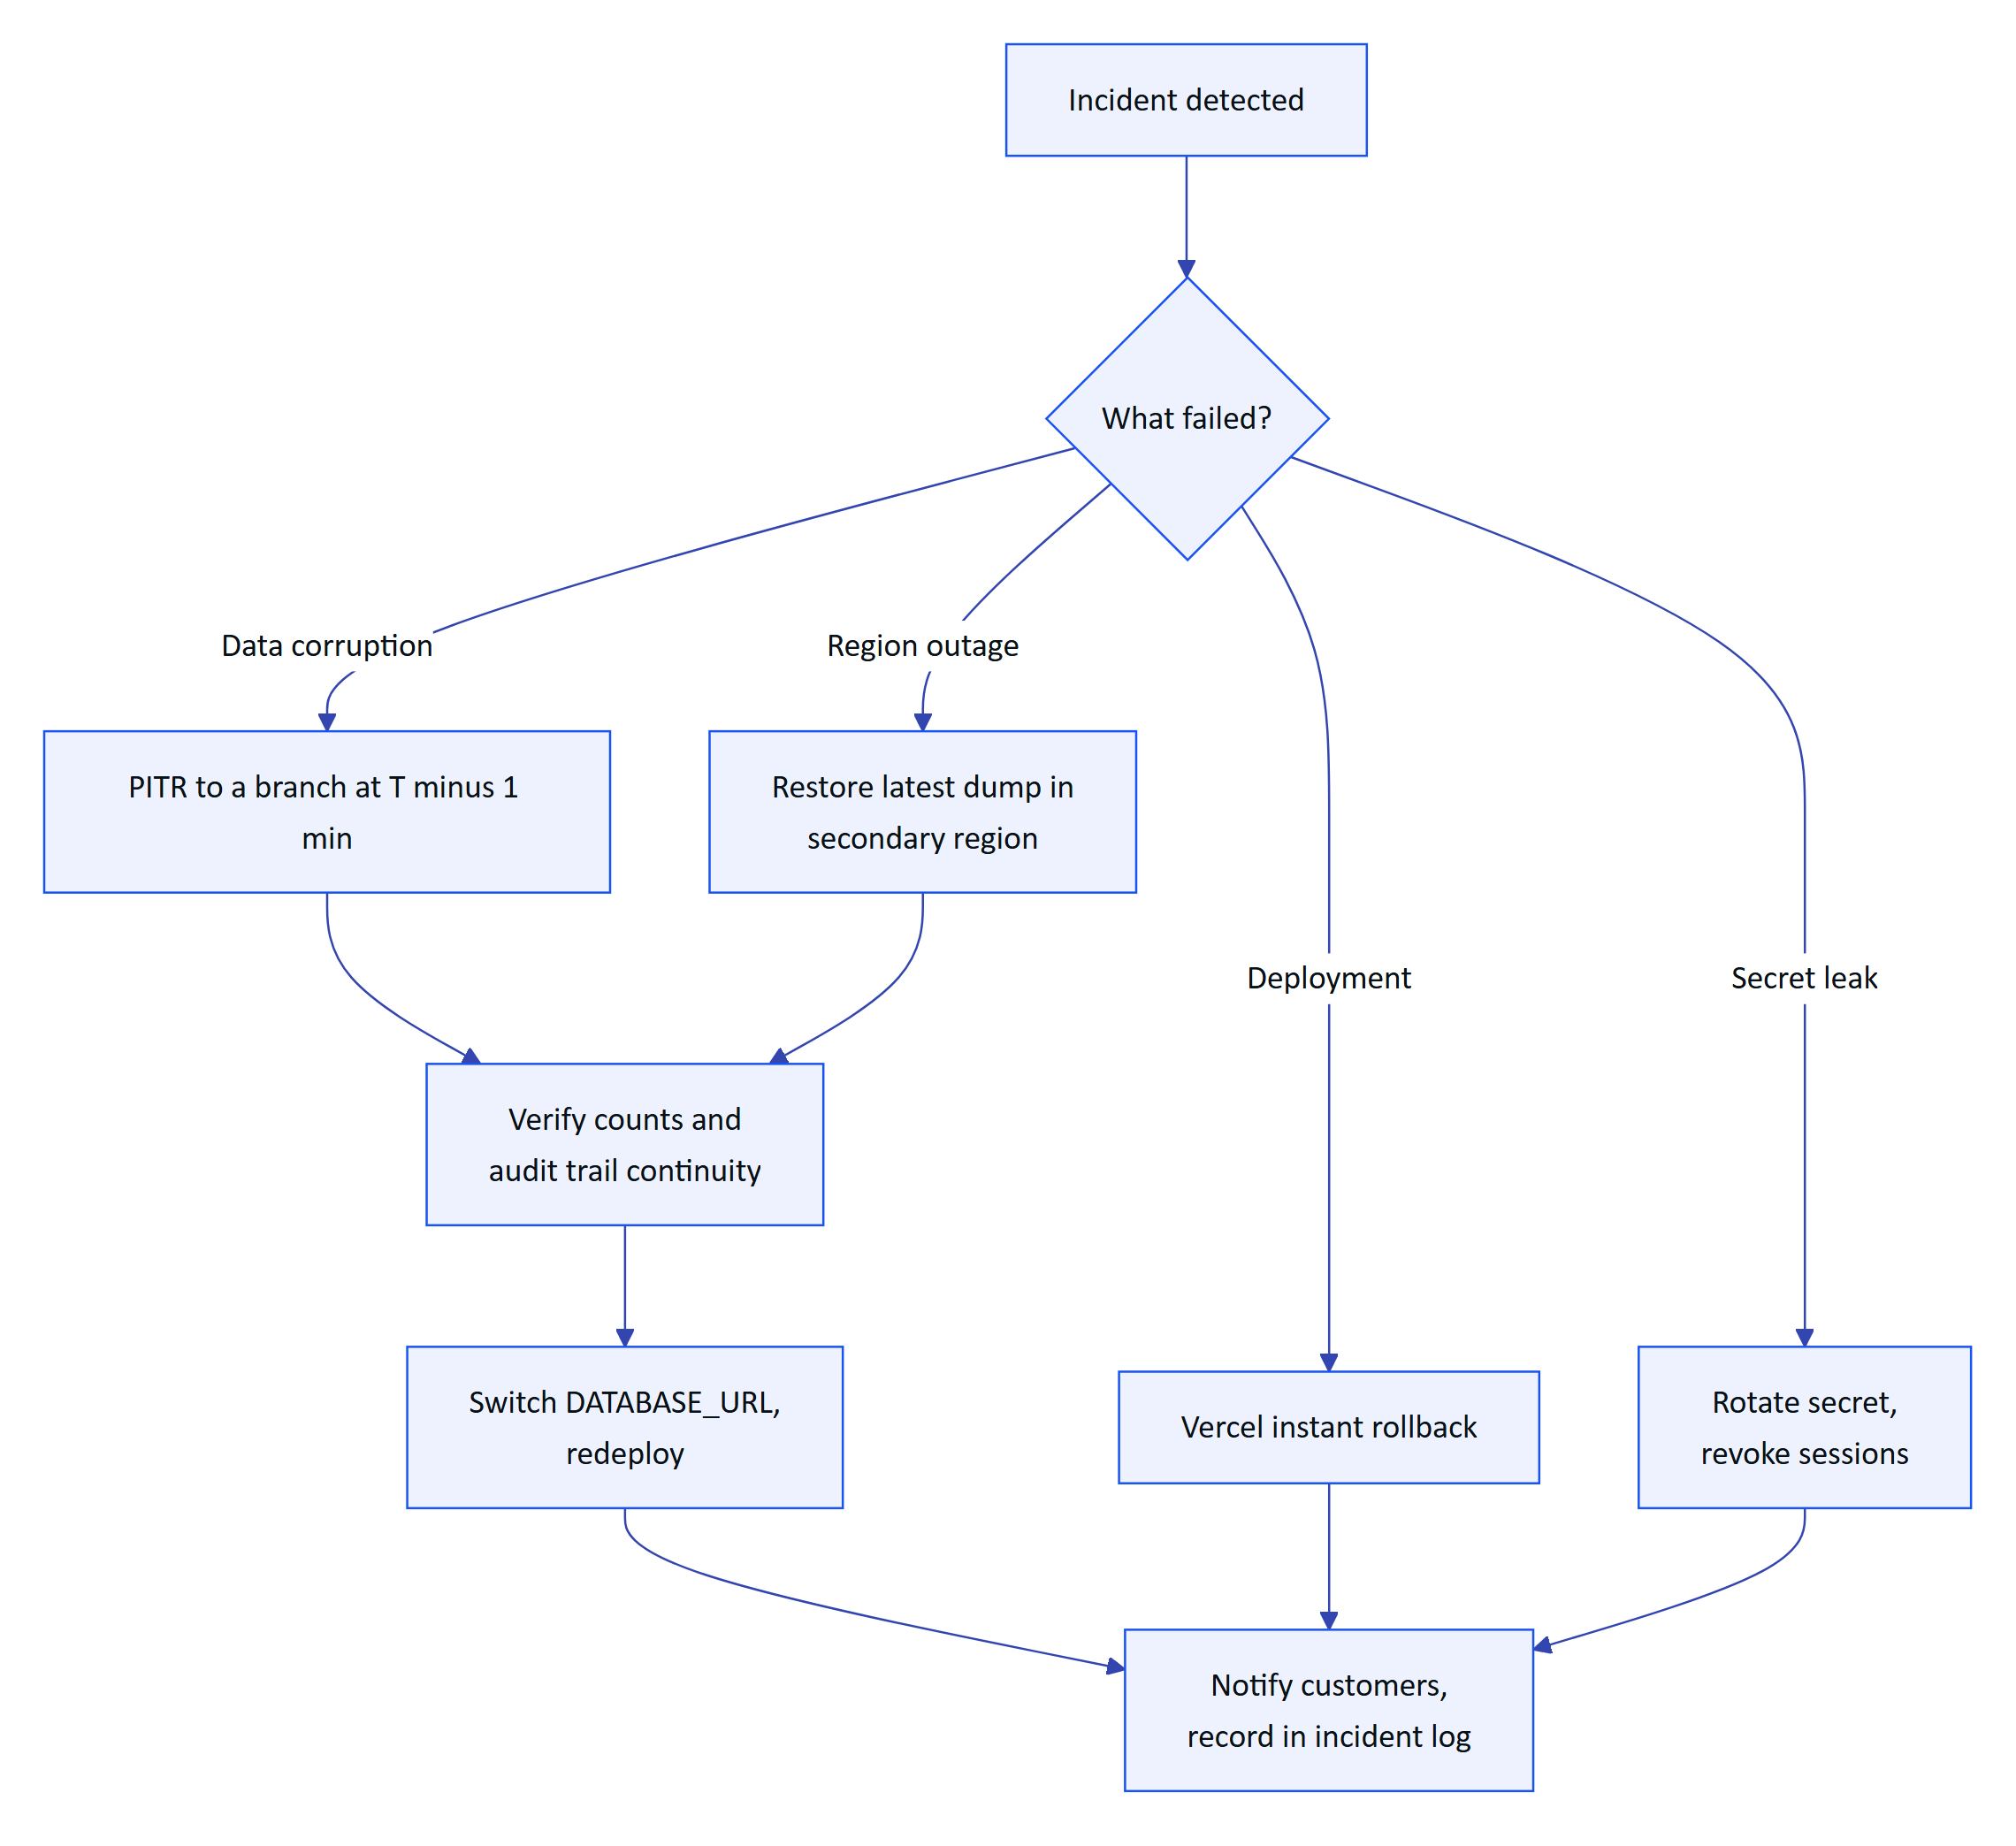
Figure 14. Disaster recovery decision flow

12.4 Restore runbook
- Declare the incident and assign an incident lead (see HFG-SEC incident response).
- Freeze writes if corruption is spreading: suspend affected organizations with POST /api/platform/organizations/:id/status (modules/org.ts), or put the project behind Vercel's maintenance page.
- Identify the restore point from the audit trail (audit_events.created_at of the first bad action) or the migration time in the deployment log.
- Create a Neon branch at that point. Never restore over the live branch.
- Run verification queries on the branch: row counts per organization, newest telemetry timestamp per site, latest audit_events id, and a login with a test account.
- Decide: switch the production DATABASE_URL to the restored branch, or copy specific rows back.
- Redeploy so every function instance reconnects. Run the smoke test.
- Reconcile: gateways replay buffered readings (ingest is idempotent per sensor and timestamp); users are told which window of manual entries must be re-entered.
- Record timings against RPO and RTO; file the post-incident review within five business days.
IMPORTANT
A restore drill runs every quarter on staging, timed end to end, with results recorded. A backup that has never been restored is not a backup.

13 Scaling and capacity

13.1 What limits scale today
Table 29. Backup schedule
Component | Limit | Mitigation | Status
Serverless function duration | 60 s (maxDuration) | SSE streams end at 50 s and resume; batch jobs | Built
Postgres connections | 3 per instance; many instances can exhaust the pooler | Neon pooled endpoint; alert at 80% | Built (pool), Planned (alert)
Realtime | DB polling every 1.5 s per open stream | Topology B with in-memory or Redis bus for large tenants | Partial
Rate limiting | @fastify/rate-limit is in memory per instance | Shared store (Redis or Vercel Firewall rules) | Partial
Telemetry table growth | Unbounded; unique (sensor, ts) index | Monthly partitions or TimescaleDB beyond about 50 M rows | Planned
Audit page images | Base64 in audit_document_pages.data (up to 6 pages of 900 KB each per document) | Move to object storage, keep a key in Postgres | Planned
Request body | 1 MB global, 8 MB for audit uploads | Direct-to-storage uploads for large media | Built limits

13.2 Capacity model
The model assumes a typical plant with 40 online instruments reporting every 60 seconds, 15 active users, 2 pairs of glasses and 20 audit scans a day. These are planning estimates, not measurements.
Table 30. Scaling constraints
Scale | Plants | Readings per day | Telemetry rows per year | Audit scan storage per year | Peak API req/s
Pilot | 2 | 115 k | 42 M | 30 GB | 5
Early commercial | 10 | 576 k | 210 M | 150 GB | 20
Growth | 50 | 2.9 M | 1.05 B | 750 GB | 90
Scale | 200 | 11.5 M | 4.2 B | 3 TB | 350

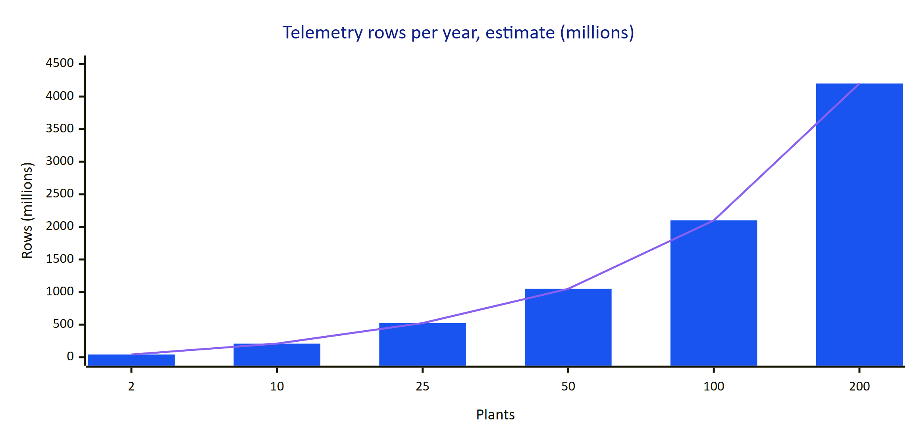
Figure 15. Estimated telemetry rows per year by number of plants (millions, planning estimate)
Practical thresholds from the model:
- Up to about 10 plants, Topology A with a single Neon database and no partitioning is comfortable.
- Between 10 and 50 plants, partition telemetry_readings by month, move audit images to object storage, add downsampled rollups for charts (the history endpoint already aggregates by bucket in modules/telemetry.ts), and move realtime for the largest tenants to Topology B.
- Beyond 50 plants, consider a time-series extension (TimescaleDB) or a dedicated telemetry store, and shard large tenants into their own database.

14 Cost model
All figures are indicative monthly costs in US dollars at 2026 list prices, before tax, for planning only. They must be checked against current vendor pricing and are not quotes.
Table 31. Capacity estimates by scale (planning assumptions)
Line item | Demo | Pilot (2 plants, 20 users) | Early commercial (10 plants, 150 users) | Growth (50 plants, 750 users)
Vercel | 0 (Hobby, non-commercial) | 40 (Pro, 2 seats) | 150 (Pro, usage) | 800 (Pro or Enterprise)
Postgres (Neon) | 0 | 70 | 300 | 1,200
Object storage and egress | 0 | 5 | 30 | 150
Anthropic (vision and assistant) | 0 to 20 | 150 | 600 | 2,500
Observability (logs, errors, uptime) | 0 | 50 | 200 | 700
Email delivery | 0 | 0 to 20 | 20 | 50
CI minutes and artefacts | 0 | 0 to 20 | 50 | 100
Total (approximate) | under 20 | about 350 | about 1,350 | about 5,500

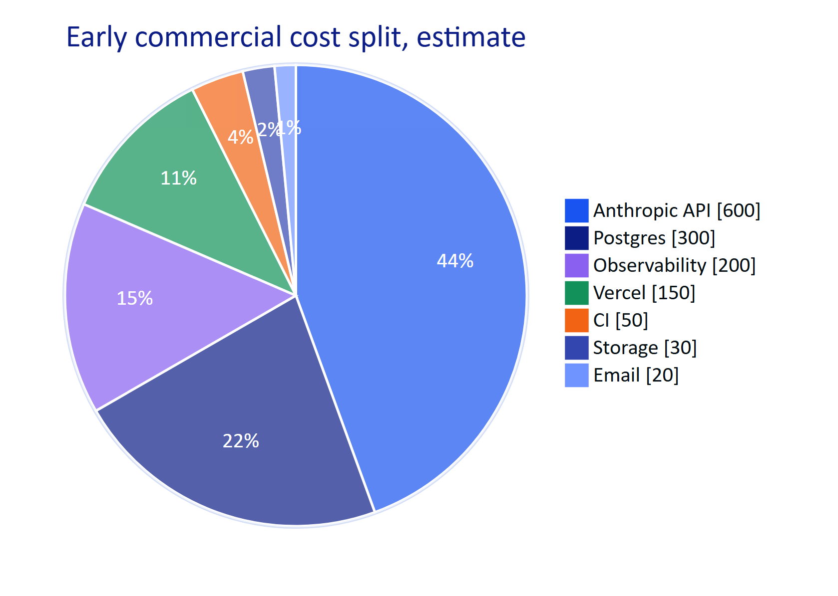
Figure 16. Indicative cost split at early commercial scale (estimate)
Observations:
- AI usage is the largest variable cost. It scales with audit scans and voice questions, not with users. Each organization needs a monthly AI budget with alerts, and the rules engine remains the free fallback.
- Database cost grows with telemetry retention. Downsampling raw data after 2 years (see HFG-SEC retention) is the main cost lever.
- Topology C shifts infrastructure cost to the customer but adds support cost on our side (offline upgrades, on-site visits). Price it as an annual licence plus a support fee.
- Topology A-IN may cost 10 to 30% more than the same footprint in a larger region because of regional pricing and the switch from Vercel Blob to S3.

15 India data residency and regulatory hosting
Hydris is an Indian company whose first customers are Indian plants. Residency is a selling point and in some cases a hard requirement.
Table 32. Indicative monthly infrastructure cost (USD, estimates)
Source | What it says (summary) | Effect on hosting
Digital Personal Data Protection Act 2023 | No blanket localisation; the government may restrict transfer of personal data to notified countries | Personal data (user names, emails, IPs) may leave India unless a restriction applies; keep it in India by default for public-sector buyers
DPDP Rules 2025 | Operational rules on notice, consent, security safeguards, breach reporting and retention, with phased commencement | Breach-reporting and log retention processes must be in place before the obligations apply
CERT-In Directions (April 2022) | Report specified incidents within 6 hours; keep ICT system logs for a rolling 180 days within Indian jurisdiction | Log drain to an India-hosted store; incident process with a 6-hour clock
CPCB and State Pollution Control Board consent conditions | Continuous monitoring data must be retrievable and unaltered; some boards require OCEMS feeds to their servers | Hydris is not the regulatory OCEMS feed; it must preserve records, provenance and audit trails
Customer contracts (PSUs, municipal corporations, smart city SPVs) | Frequently require data in India and named subprocessors | Topology A-IN or C; subprocessor list in the DPA
MeitY cloud empanelment | Government departments may require empanelled cloud service providers | Use an empanelled provider (AWS, Azure, Google Cloud India regions) for government tenders; Vercel and Neon empanelment must be checked

WARNING
This table is an engineering summary to guide design, not legal advice. Residency commitments in contracts must be reviewed by counsel, and dates in the DPDP Rules phase-in must be confirmed against the official gazette.

15.1 Residency design
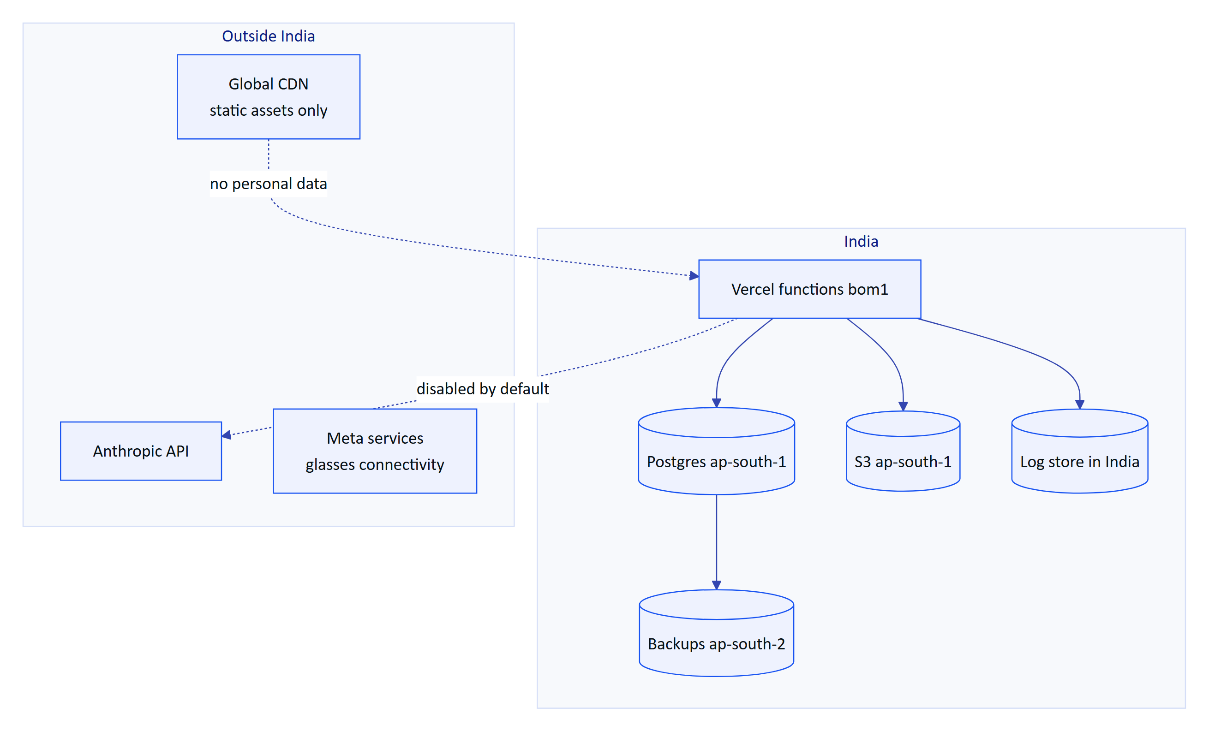
Figure 17. Data flows for a strict-residency tenant on Topology A-IN
Rules for a strict-residency tenant:
- All stores (database, objects, logs, backups) are in India.
- AI features are off unless the customer accepts processing outside India in writing. The organization record already has a region field (modules/org.ts); a per-organization AI switch keyed on it is Planned.
- On-device OCR (ML Kit on the phone) keeps working without any cloud AI.
- Meta glasses connectivity uses Meta services; disclose it as a subprocessor for glasses features.
- Support staff access production data only from India or under a documented exception.

16 Customer onboarding and provisioning

16.1 Provisioning flow
A new customer organization is created by a Hydris platform administrator through POST /api/platform/organizations (apps/api/src/modules/org.ts). The call creates the organization with its name, slug, region and timezone, creates an org_admin invitation for the customer's first administrator, writes an organization.created audit event, and returns the invitation link. Because email is not wired yet, the platform admin currently sends that link to the customer by a separate secure channel.
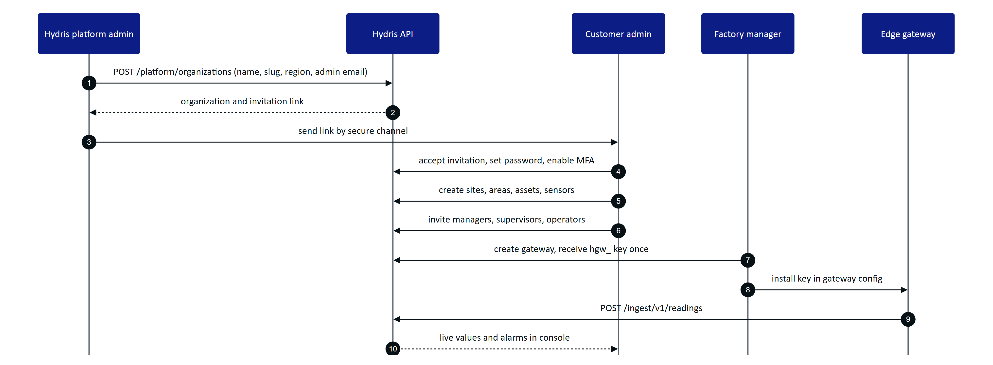
Figure 18. Customer provisioning from contract to first live reading

16.2 Onboarding steps and owners
Table 33. Indian regulatory considerations for hosting (summary, not legal advice)
Step | Owner | Done when
Contract, DPA, topology and region chosen | Hydris sales and customer | Signed order form names topology and AI setting
Environment ready | Hydris platform engineering | Production project, database, secrets and cron verified
Organization created | Hydris platform admin | organization.created audit event
First admin activated with MFA | Customer admin | member.invitation_accepted, auth.mfa_enabled events
Plant model built (sites, areas, assets, sensors, alarm rules) | Customer with Hydris solutions engineer | Plant map and sensor list complete
Users invited with site scopes | Customer admin or factory manager | All pilot users active
Gateway installed and keyed | Customer OT team with Hydris | First readings within freshness window
Phones enrolled in MDM, apps installed | Customer IT | Apps open and sign in
Glasses paired and assigned | Customer supervisor | Devices show as active in the console
Procedures and inspection templates loaded | Customer | First guided inspection completed
Training and go-live sign-off | Customer and Hydris | Signed acceptance

17 Go-live checklist
The checklist below gates the first customer pilot on Topology A. Items already true in the code are ticked.

17.1 Platform
- ☑ API runs in-process on Vercel with migrations under an advisory lock
- ☑ Refresh cookies are HttpOnly, SameSite=Strict, Secure in production
- ☑ Attachments use a private store served only through authorized routes
- ☐ Separate production Vercel project; demo project keeps hydrisview.vercel.app
- ☐ Production Neon database in the agreed region, PITR enabled, pooled URL
- ☐ Runtime database user is not the owner; RLS verified with a cross-tenant test
- ☐ JWT_SECRET, DATA_KEY, CRON_SECRET generated, stored, DATA_KEY escrowed offline
- ☐ DEMO_MODE=false set explicitly in production; SIMULATOR_ENABLED=false
- ☐ REALTIME_MODE=db, PUBLIC_APP_URL set to the customer-facing domain
- ☐ Cron schedule changed to every minute (Vercel Pro) or external scheduler in place
- ☐ Vercel function region matches the database region
- ☐ Custom domain with TLS; HSTS confirmed

17.2 Pipeline
- ☐ GitHub Actions CI with required checks on main
- ☐ Migrations run as a pipeline step with approval
- ☐ Release tags and changelog
- ☐ Android upload key in CI; release builds no longer signed with the debug key
- ☐ Meta DAT application ID and client token injected in CI

17.3 Operations
- ☐ Log drain, error tracking and uptime checks live
- ☐ Alerts for 5xx, ingest lag, cron age and token reuse routed to on-call
- ☐ Deep health check covering the database
- ☐ Backup dump job and first restore drill completed and timed
- ☐ Incident response contacts and CERT-In reporting path documented
- ☐ Email provider wired for invitations and password reset

17.4 Customer
- ☐ DPA signed with subprocessor list (Vercel, Neon, Anthropic if enabled, Meta for glasses)
- ☐ AI processing choice recorded per organization
- ☐ Gateway tested end to end with buffered replay
- ☐ Training delivered; site privacy signage for glasses in place

18 Known gaps and decisions
Table 34. Onboarding steps
ID | Gap | Impact | Plan | Priority
DEP-01 | No CI pipeline | Regressions and unsafe migrations can reach production | Add the proposed workflow | High
DEP-02 | Cron runs daily on Vercel | Stale-data alarms up to 24 h late | Per-minute cron on Pro or external scheduler | High
DEP-03 | Release APK signed with debug key | Cannot distribute through Play | Upload key in CI | High
DEP-04 | Email not wired | Invitations and resets need manual link delivery | Transactional email provider, purge mail_outbox after send | High
DEP-05 | No metrics, tracing or alerting | Incidents found by users | Observability stack | High
DEP-06 | Audit page images in Postgres as base64 | Database bloat, backup size, cost | Move to object storage | Medium
DEP-07 | No retention or purge jobs | Unbounded growth of sessions, mail and telemetry | Retention jobs per HFG-SEC schedule | Medium
DEP-08 | hydris_url compiled into Android builds | One build per customer | MDM managed configuration | Medium
DEP-09 | Node version mismatch (22 in engines, 24 in Dockerfiles and Vercel guide) | Inconsistent runtime behaviour | Standardize | Low
DEP-10 | Per-instance rate limiting | Limits weaker under many instances | Shared limiter or edge firewall rules | Medium
DEP-11 | Demo and production share one project today | Customer data could be added to a demo by mistake | Split projects | High
DEP-12 | Debug APK committed to the repository | Untraceable binaries | Move to CI artefacts | Low

DECISION
Topology A on Vercel and Neon remains the default for pilots. Topology B is adopted per customer only when the capacity model or a realtime requirement demands it. Topology C is offered to air-gapped plants with the glasses constraint stated up front. All production deployments wait for DEP-01, DEP-02, DEP-03 and DEP-11.

